**Final Use Case -Azure Devops**

**Project Objective:**

To build, containerize, and deploy a simple "Hello World" web application on Azure Free Tier, demonstrating fundamental DevOps practices including cloud infrastructure setup, containerization with Docker, orchestration with Azure Kubernetes Service (AKS), and automated CI/CD using Azure DevOps Classic Pipelines.

**Technologies Used:**

* Azure CLI
* Ubuntu VM
* Docker
* Azure Container Registry (ACR)
* Azure Kubernetes Service (AKS)
* Azure DevOps Classic Pipelines

**Setting Up Azure Infrastructure**

* Azure Resource Group
* Virtual Network
* Subnet
* Storage Account
* Virtual Machine
* Network Security Group
* Docker Installation on VM

sudo apt update

sudo apt install -y docker.io

sudo systemctl start docker

sudo systemctl enable docker

sudo usermod -aG docker azure-dev-user

* Git Installation on VM

sudo apt install -y git

**HTML and CSS Web Application**

Created a simple index.html with "Hello, World!" message

* hello-world-app

**-** index.html

**Containerized the App**

* Wrote a **Dockerfile** using the Nginx image
* Built the Docker image locally on the VM

Dockerfile:

FROM nginx:latest

COPY . /usr/share/nginx/html

EXPOSE 80

CMD ["nginx", "-g", "daemon off;"]

What the Dockerfile is doing?

1.Docker starts from the official Nginx image.

2.Your HTML files are copied into the Nginx directory.

3.Port 80 is exposed for web traffic.

4.Nginx tarts and serves your website on port 80.

Commands used to build and run the image locally:

docker build -t hello-world-app .

docker run -p 80:80 hello-world-app

By mapping ports like this:

* When you open http://localhost on your browser, it sends a request to **port 80 on your host**.
* Docker then forwards that request to **port 80 inside the container**, where your NGINX web server is listening.

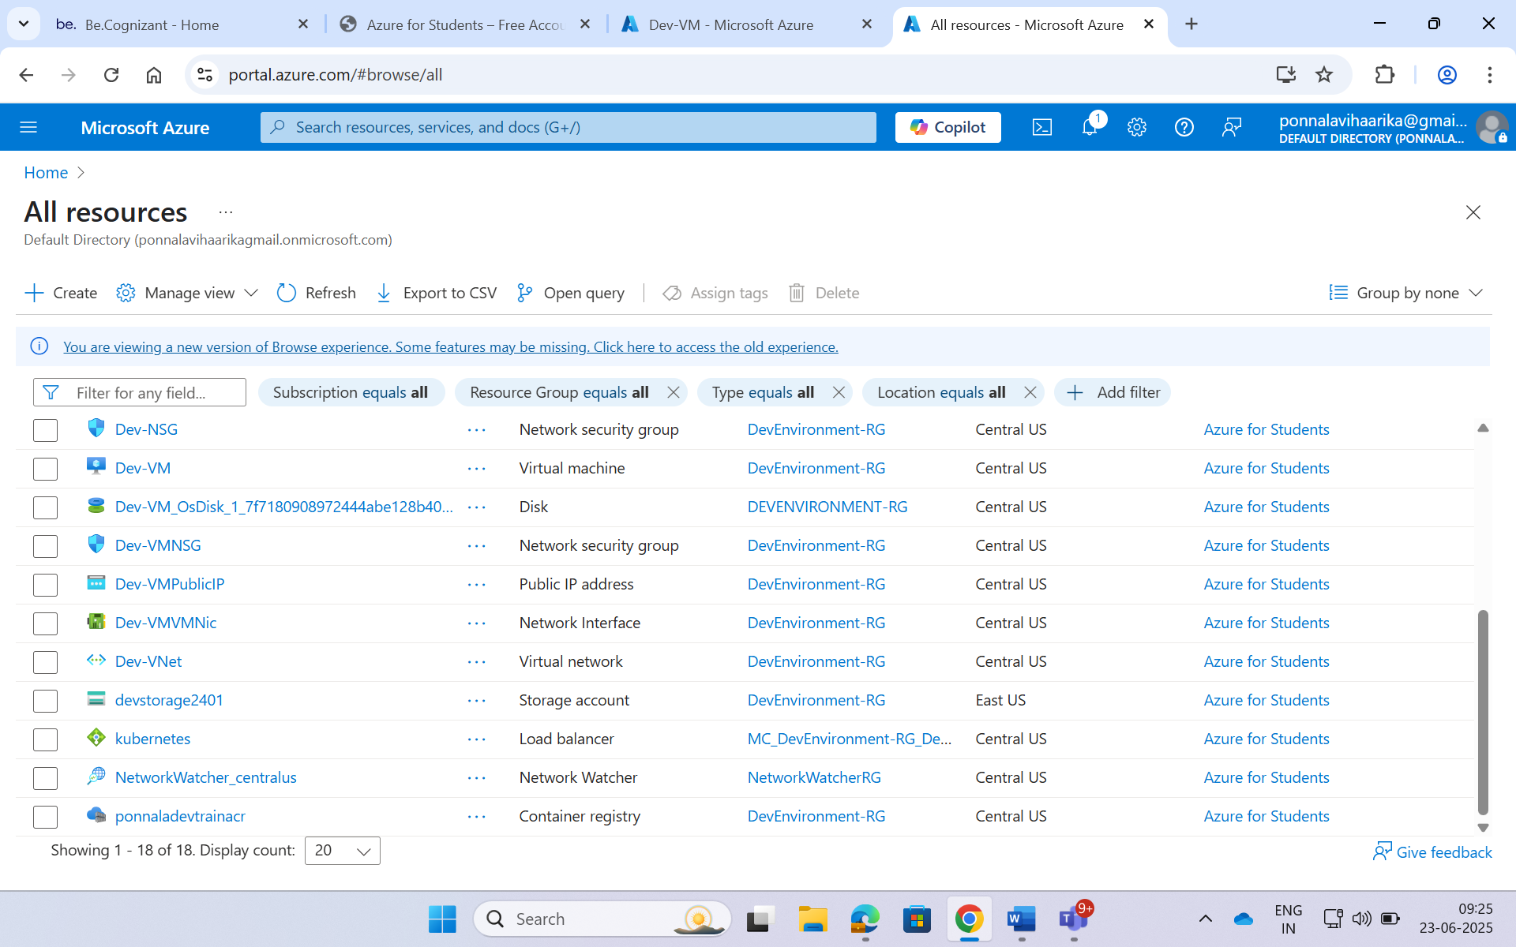

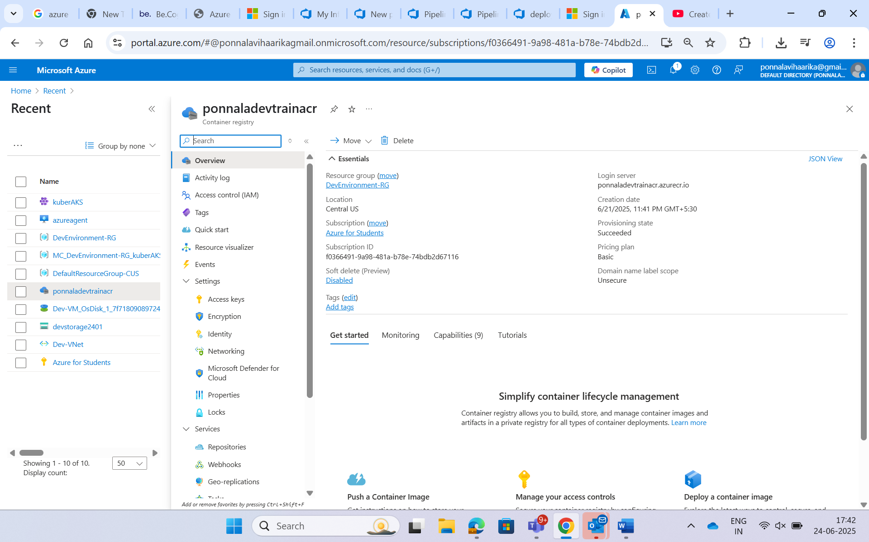

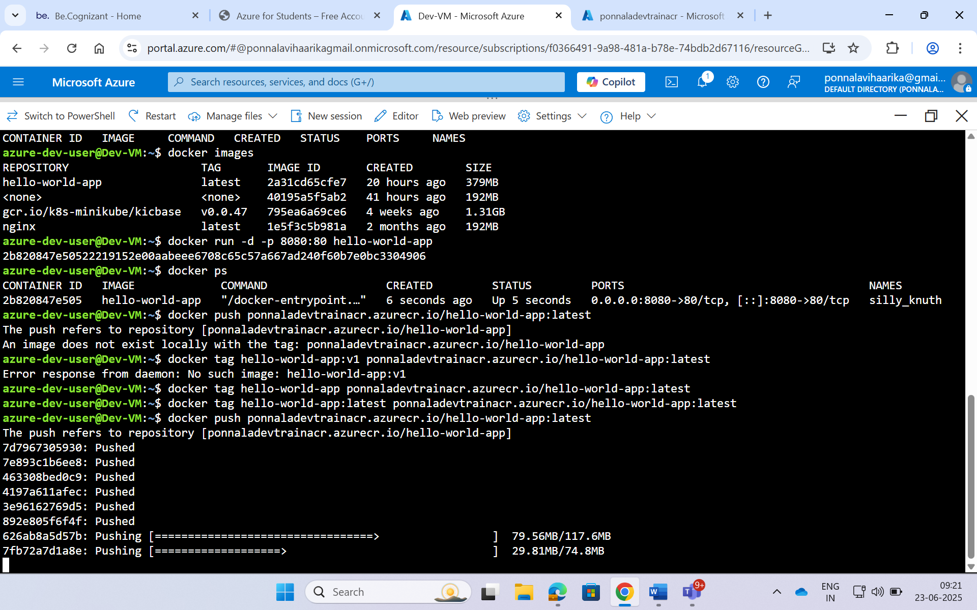

**Created Azure container Registry in Azure where you can store your Docker container images securely**

Pushed Image to ACR

* Used Cloud Shell to log in to ACR
* Tagged the image

docker push ponnaladevtrainacr.azurecr.io/hello-world-app:latest

docker tag hello-world-app:latest ponnaladevtrainacr.azurecr.io/hello-world-app:latest

* Pushed the Docker image to ACR

**Deployed to AKS**

* Wrote a **Kubernetes deployment.yaml** file
* Applied it using kubectl to deploy the container

**Exposed App Using LoadBalancer**

* Created a service.yaml file

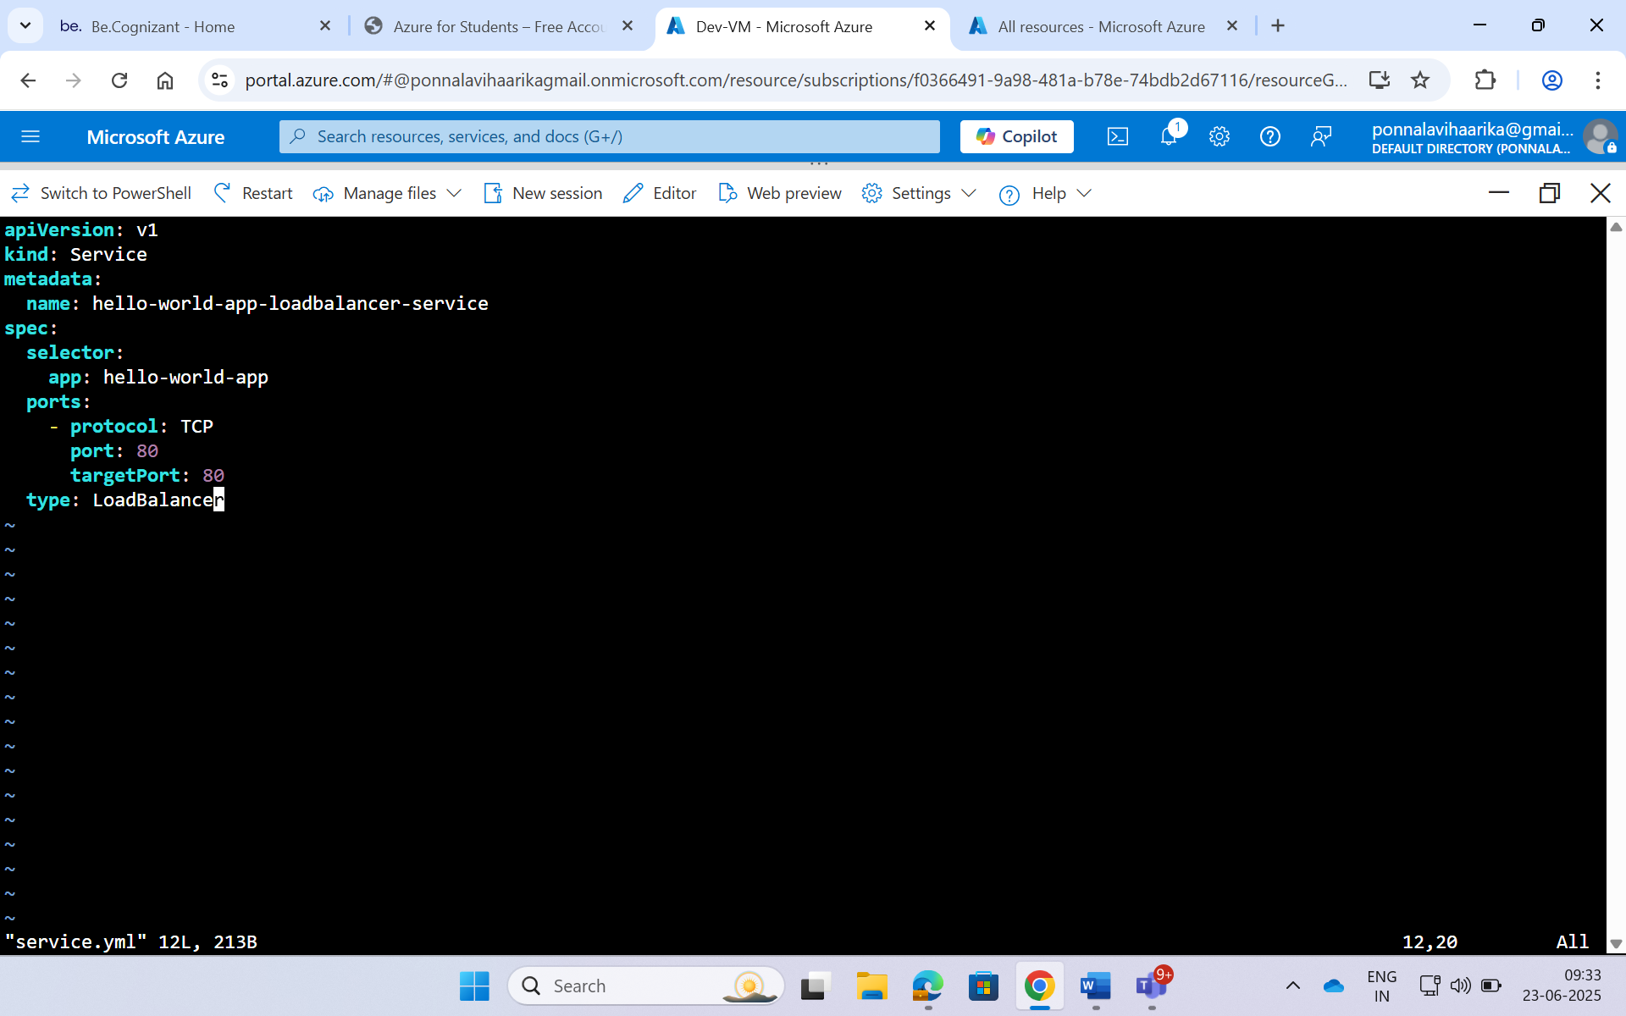

* Used Kubernetes LoadBalancer type to get a **public IP**
* App is now publicly accessible in the browser

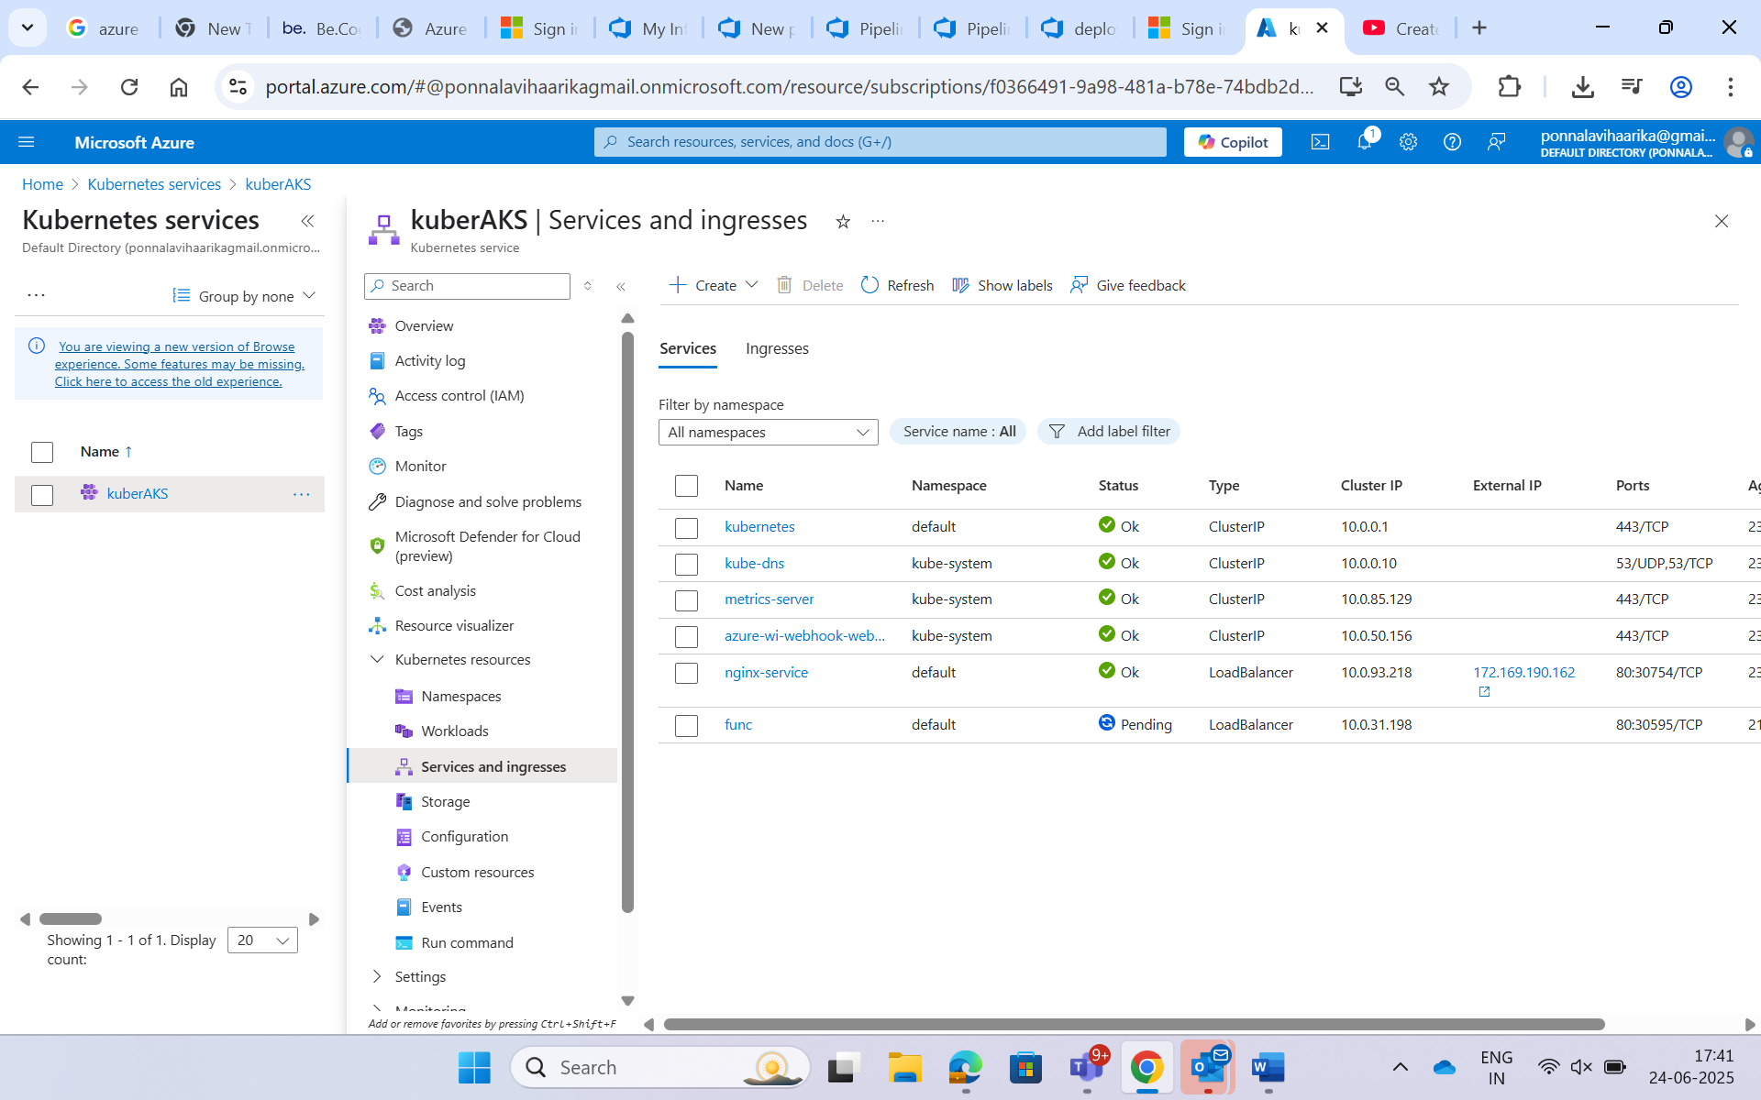



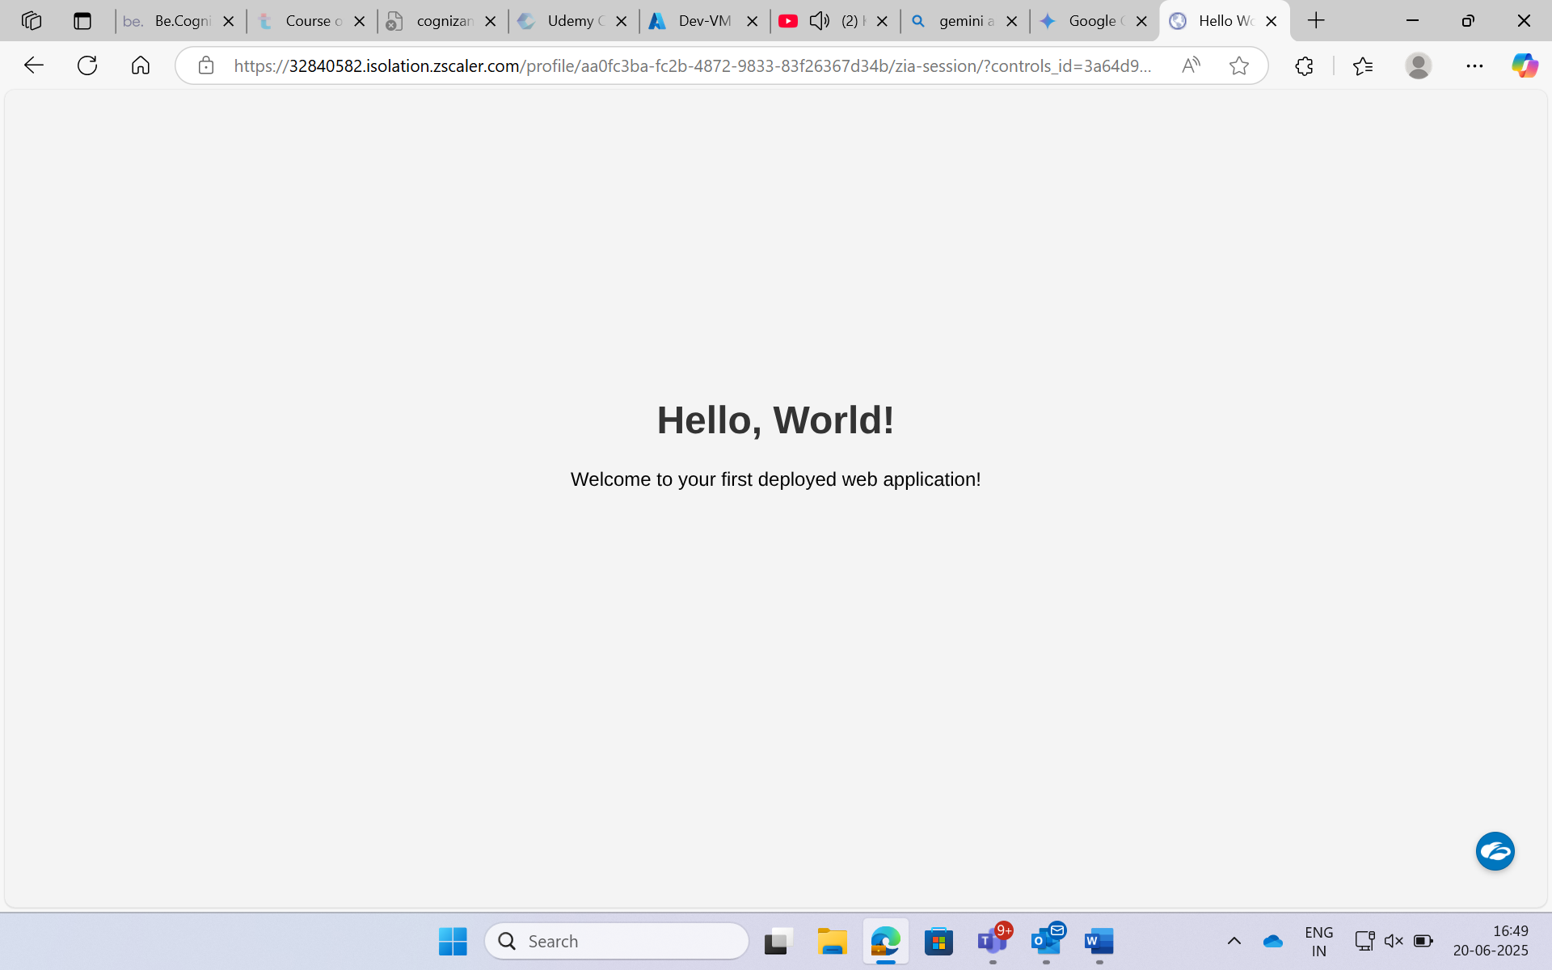

**Azure Devops**

**Continuous Integration (CI) – Build Pipeline**

To automate the building and publishing of a Docker image to Azure Container Registry (ACR), a CI pipeline was created using the Azure DevOps Classic Editor.

Navigated to **Pipelines > Builds > New Pipeline**, selected **Classic Editor**.

Chose the Azure Repos Git repository containing the application code and Dockerfile.

Started with an empty job.

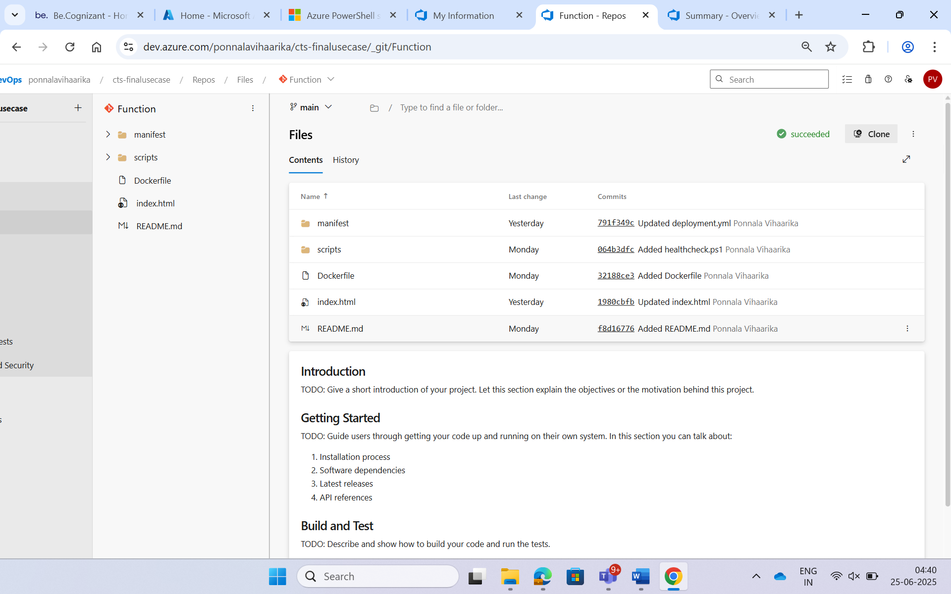

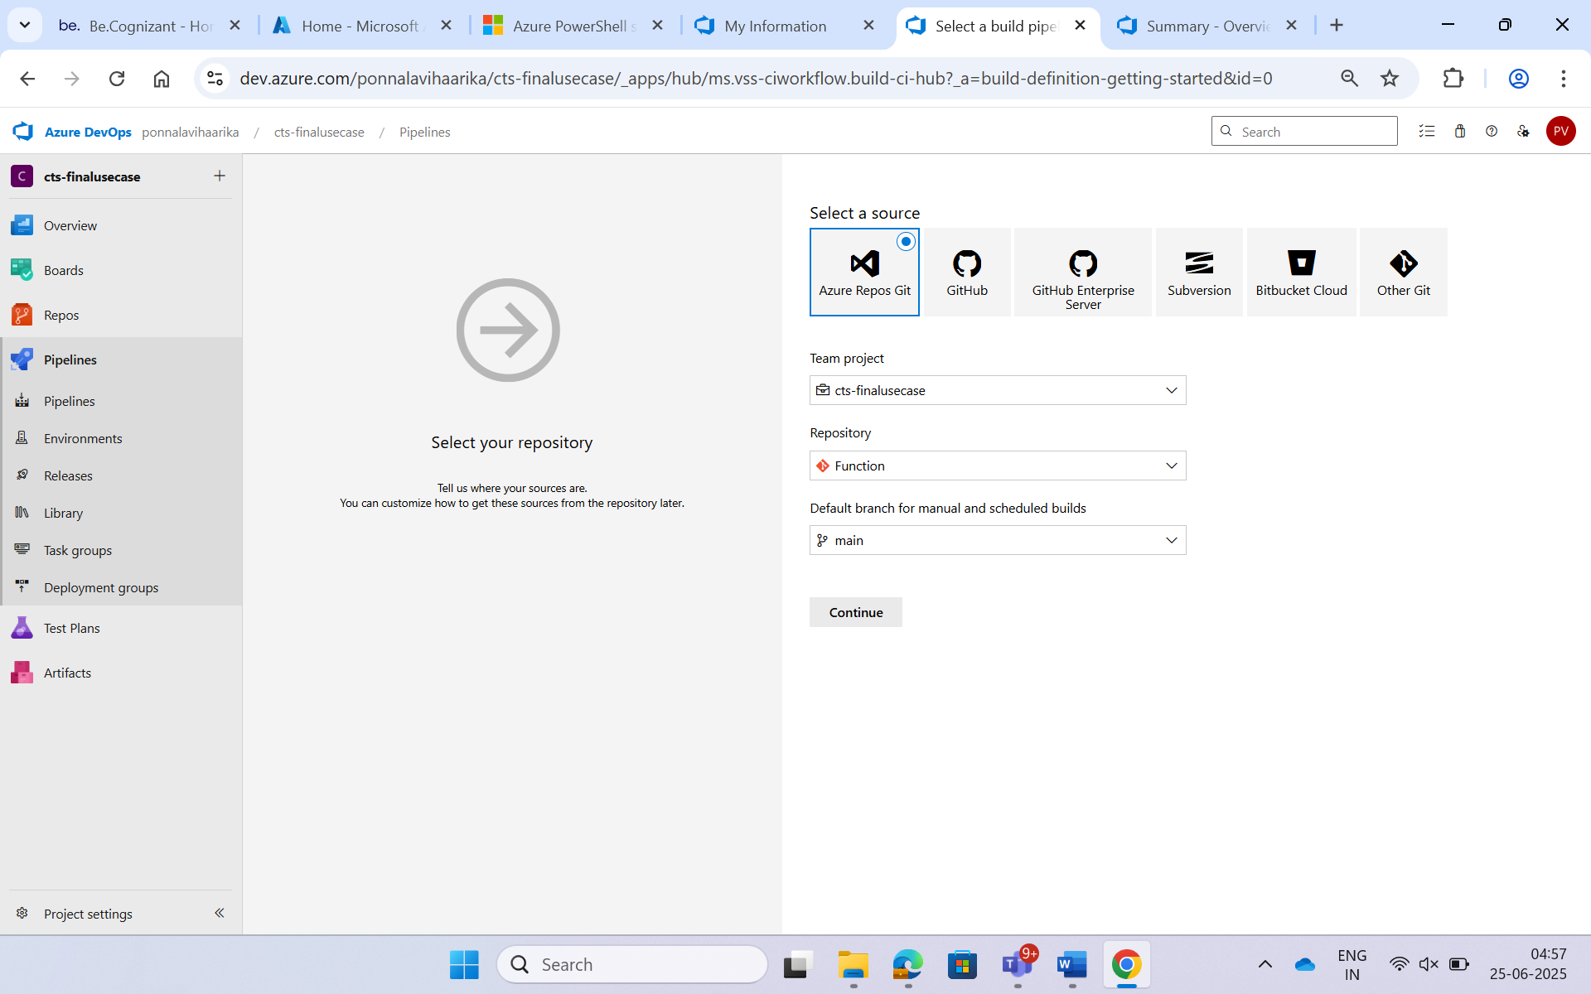

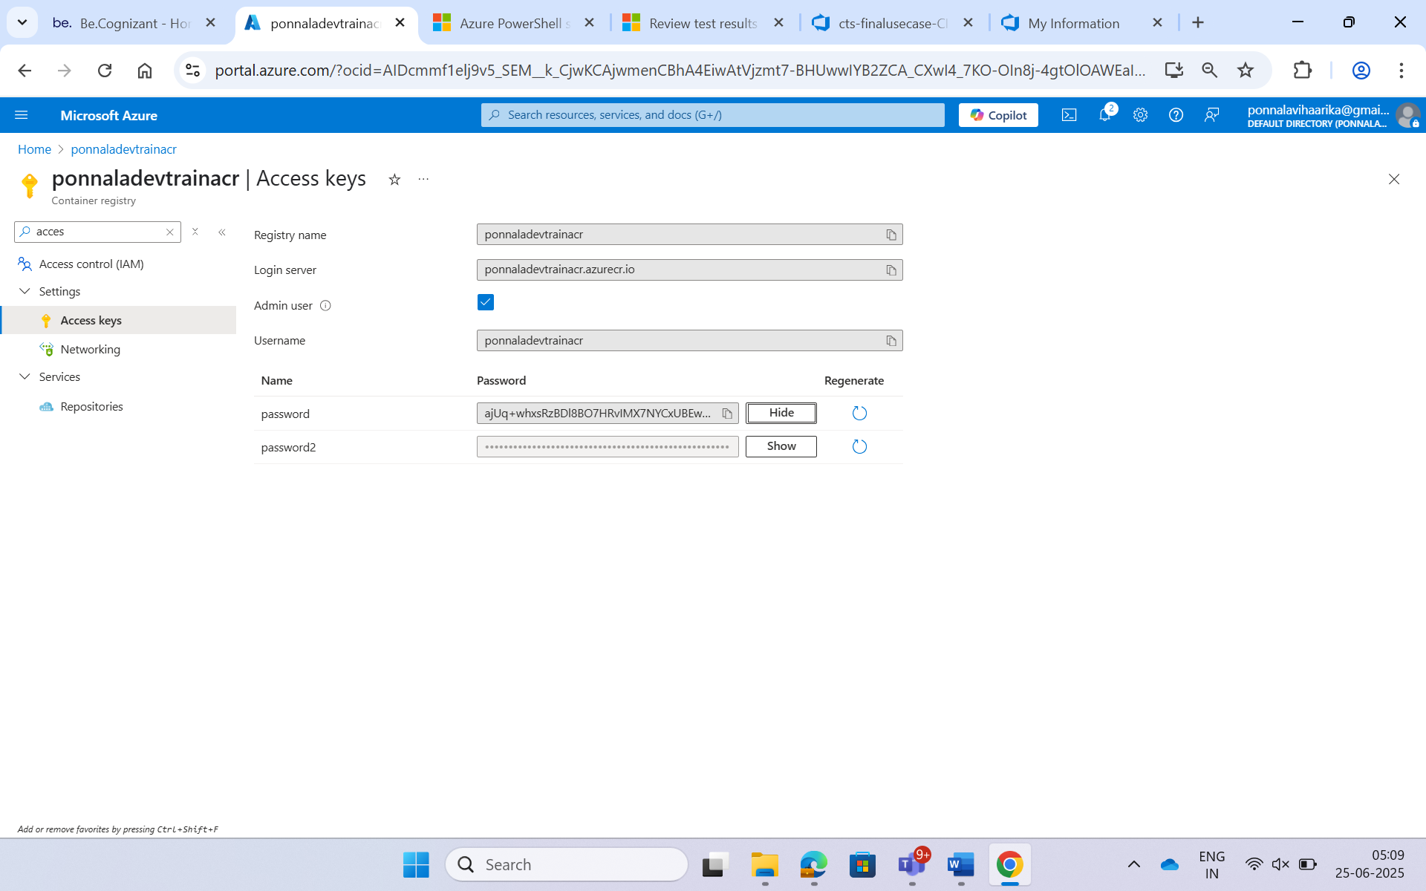

**Command given in Command Line Script:**

Used a command which chains multiple Docker and Azure commands to build, tag, log in to ACR, and push an image.

Sudo docker build -t web . && sudo docker tag web ponnaladevtrainacr.azurecr.io/hello-world-app-vigarika:$(Build.BuildId) && sudo az acr login --name ponnaladevtrainacr --username ponnaladevtrainacr --password ajUq+whxsRzBDl8BO7HRvIMX7NYCxUBEw2oD2/oBep+ACRDAcAmv && sudo docker push ponnaladevtrainacr.azurecr.io/hello-world-app-vigarika:$(Build.BuildId)

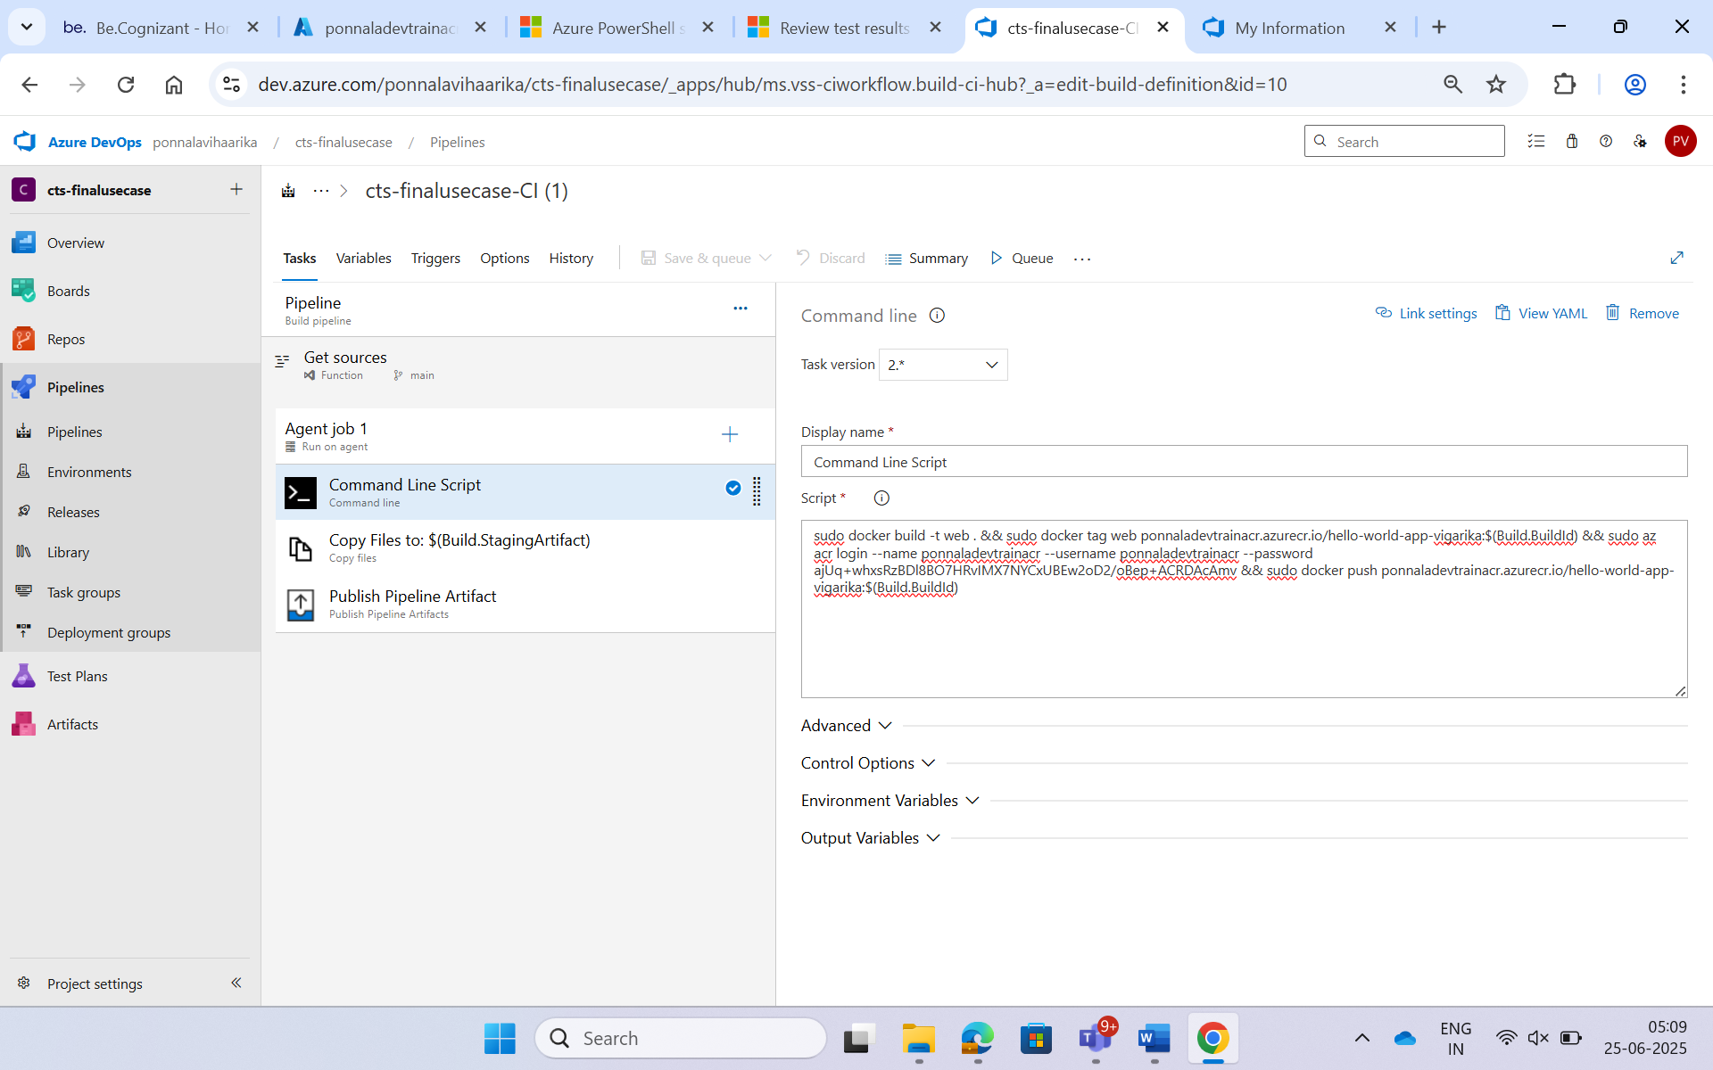

**Copy Files to: $(Build.StagingArtifact)**

The "Copy Files to: $(Build.StagingArtifact)" task in Azure DevOps is used to collect specific output files into a staging folder during the build pipeline. This prepares them to be published as build artifacts for use in the release pipeline.

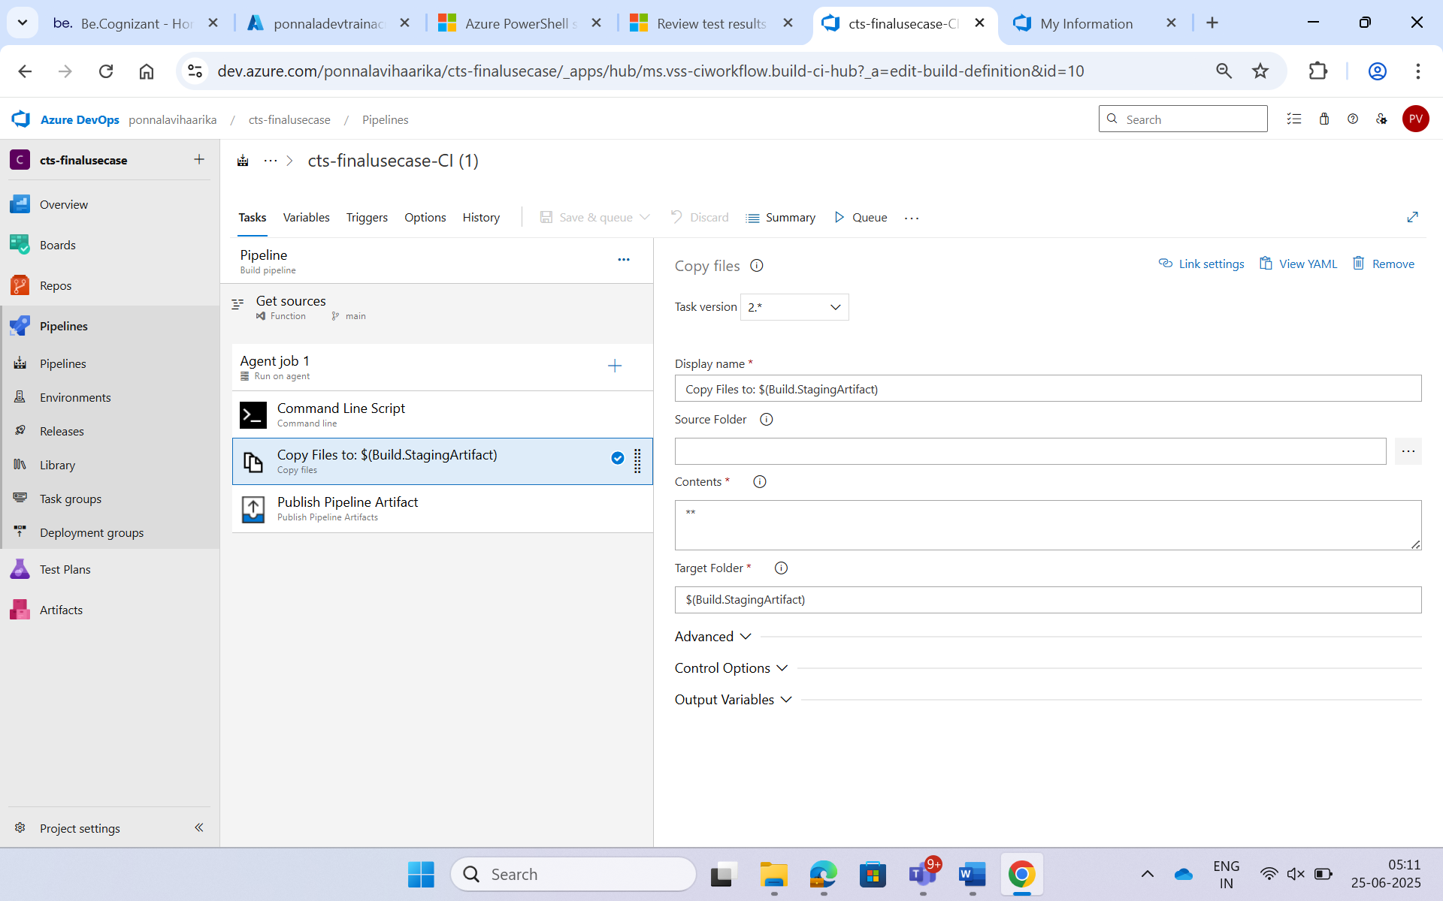

**Publish pipeline Artifact**

In Azure DevOps, $(Pipeline.Workspace) is a predefined variable that refers to the working directory on the agent where all your pipeline files, artifacts, and intermediate outputs are stored during the run.

So it is specified in the file or directory path

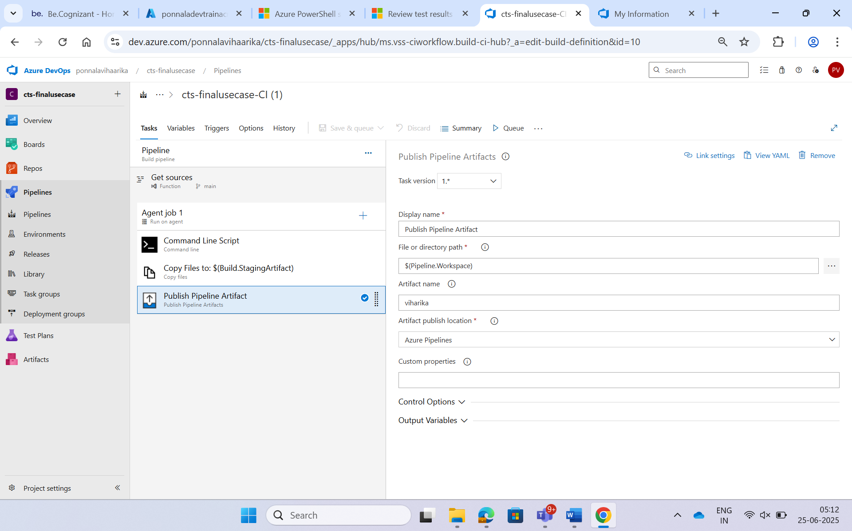

**Continuous Integration (CI) – Build Pipeline**

The **Build Pipeline** was created using Azure DevOps Classic Editor. The goal of this pipeline is to **build the Docker image** and **publish it to ACR**.

**CI Pipeline Steps:**

1. **Initialize Job**  
   Sets up the agent and environment for the pipeline to run.

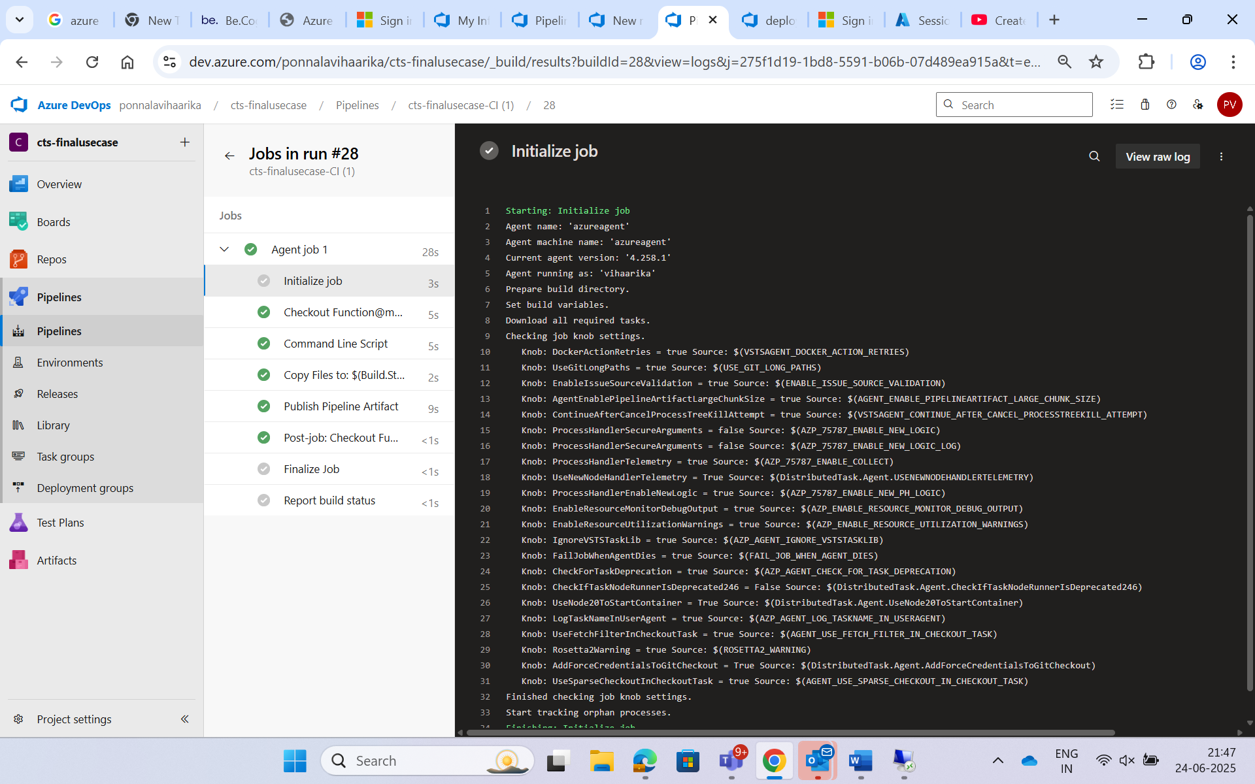

1. **Checkout Function@main to s**  
   Clones the Git repository (your project code) to the agent machine.

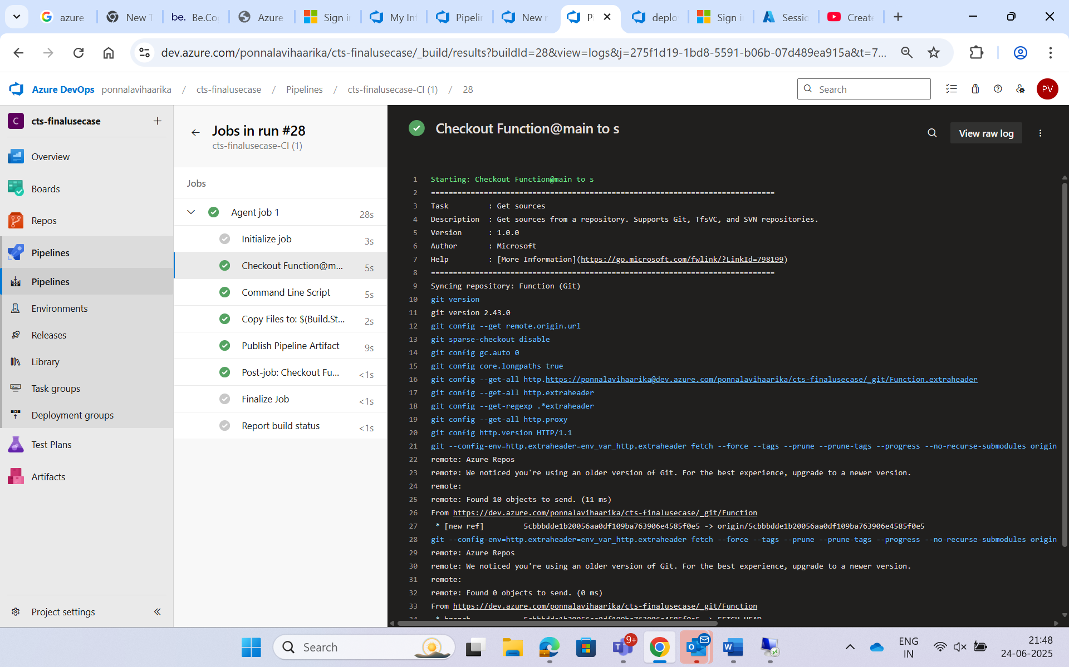

1. **Command Line Script**  
   Runs the Docker commands like:  
   docker build  
   docker tag  
   docker push  
   to build and push the image to Azure Container Registry (ACR).

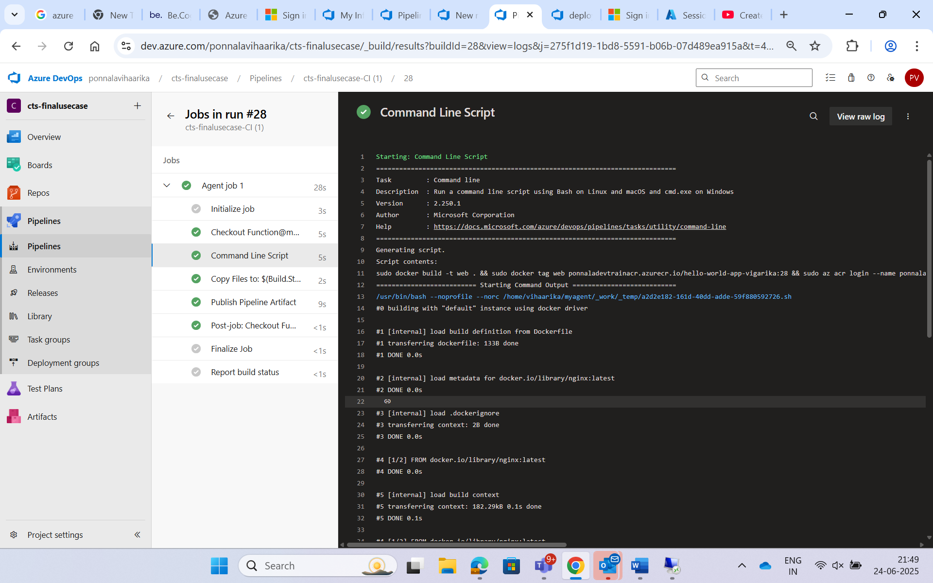

1. **Copy Files to: $(Build.ArtifactStagingDirectory)**  
   Prepares files to share between CI and CD pipelines.

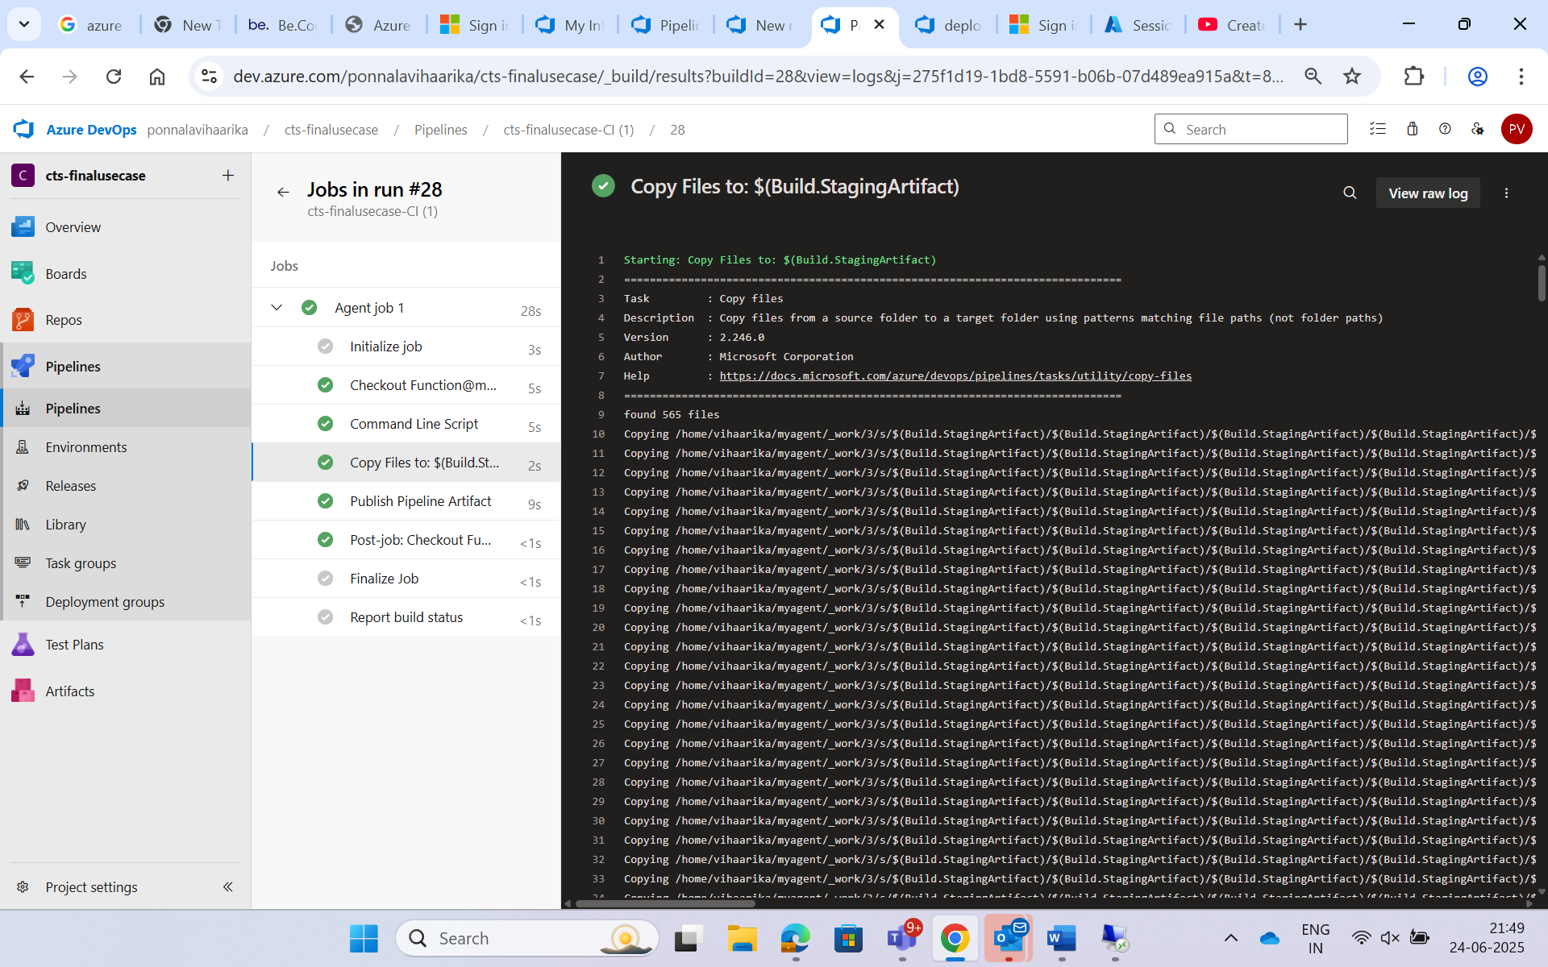

1. **Publish Pipeline Artifact**  
   Publishes the Docker metadata (like image tag info) to be used in the Release (CD) pipeline.

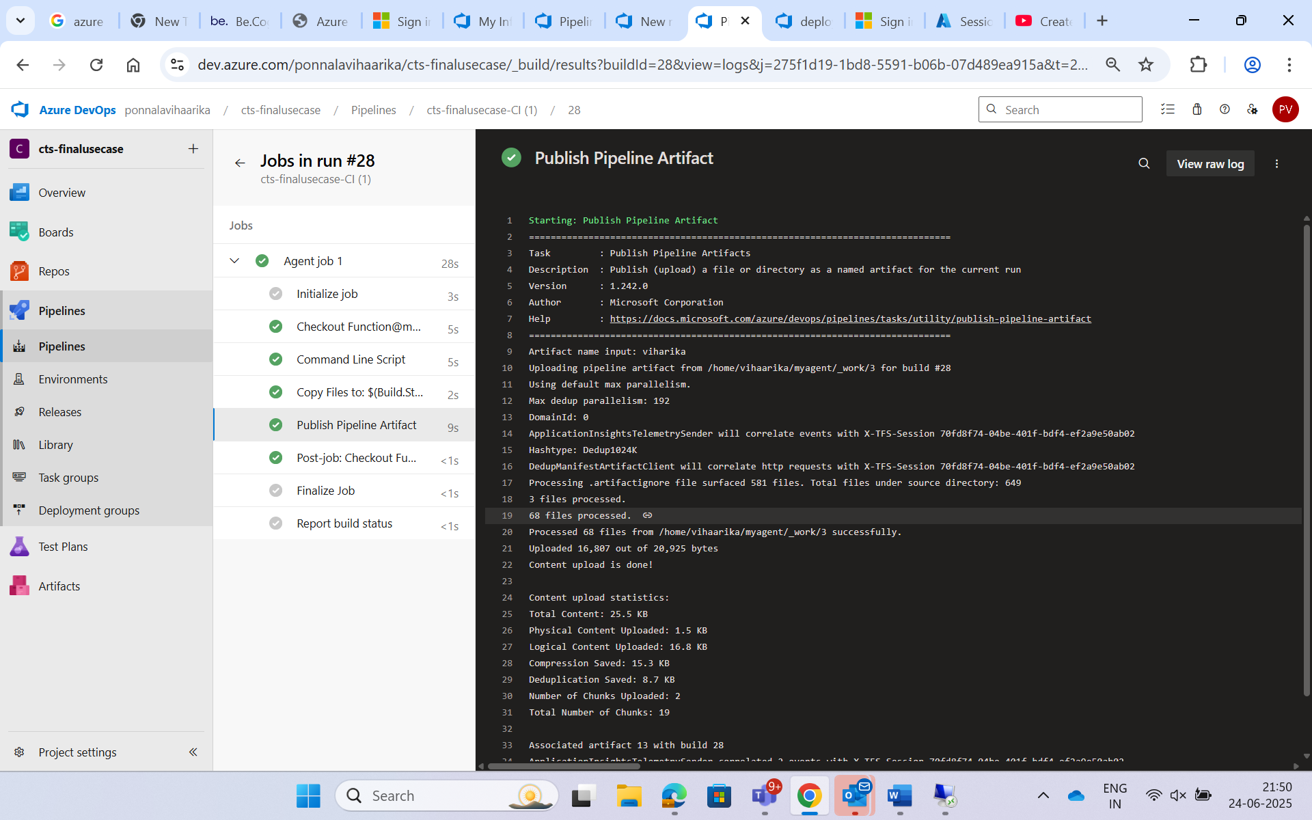

1. **Post-job: Checkout**  
   Cleans up the Git checkout after job is done.

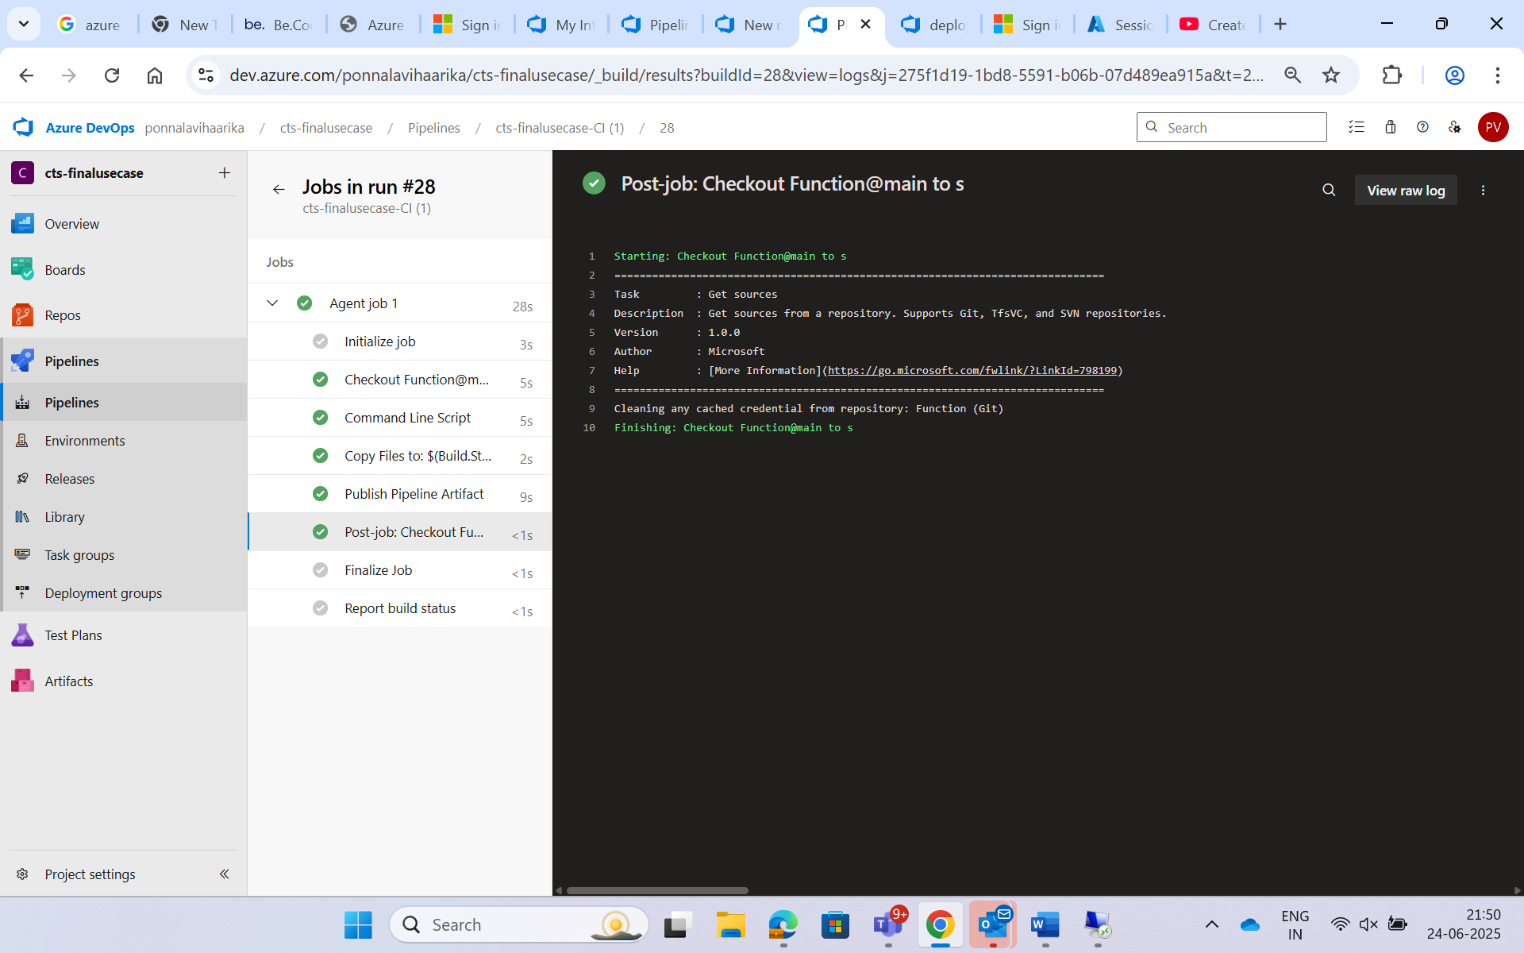

**Continuous Deployment (CD) – Release Pipeline**

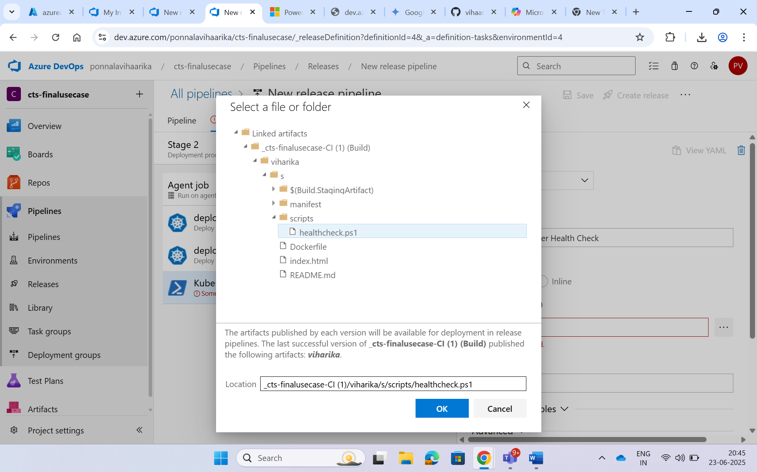

The **Release Pipeline** was created to **deploy the app to AKS** using the Docker image from ACR.

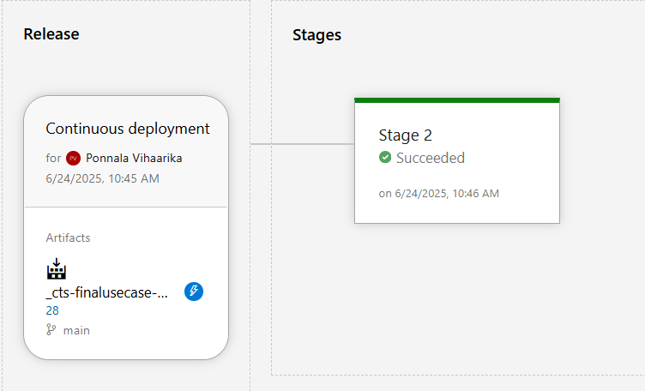

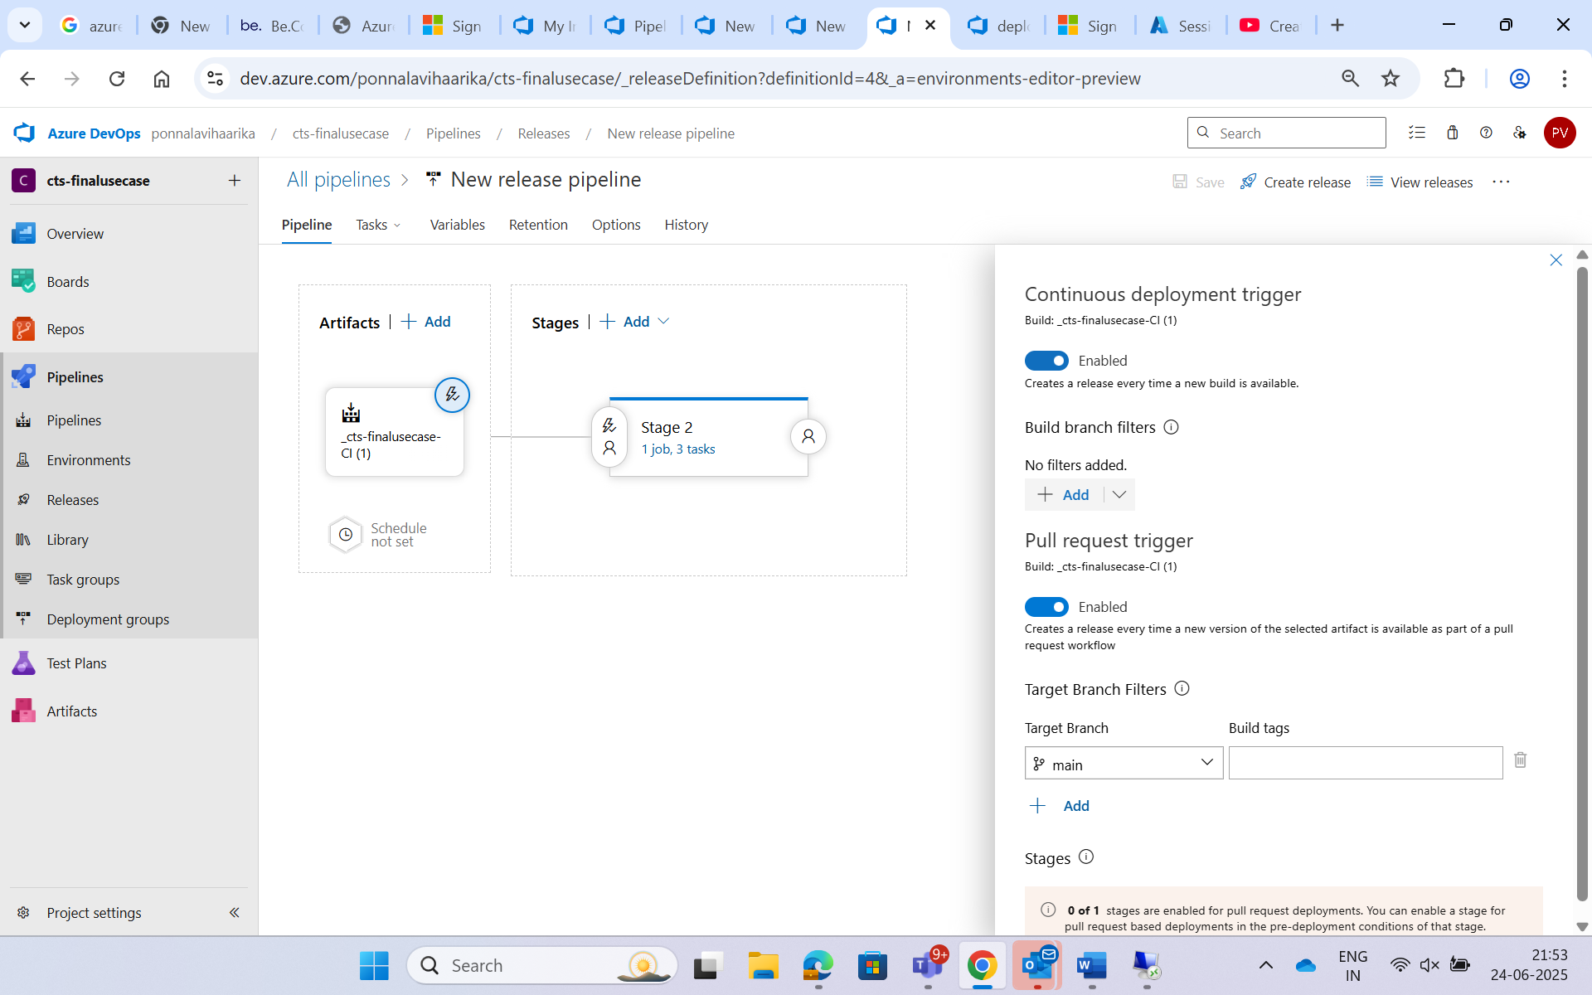

**CD Pipeline Steps:**

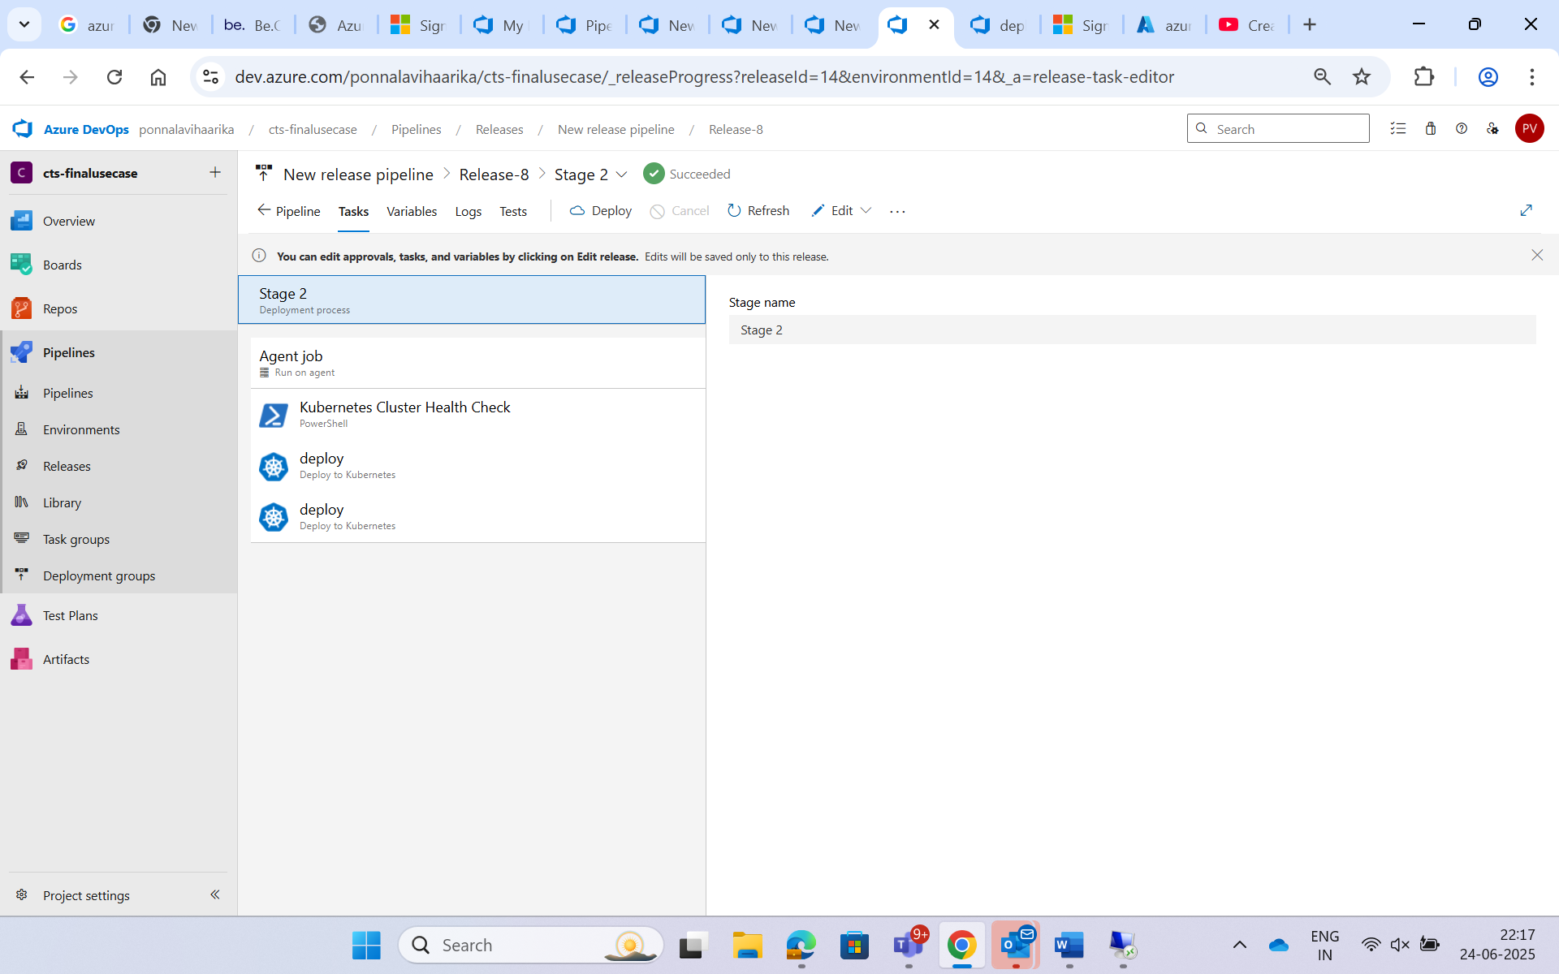

**Kubernetes cluster Health Check -** Specifying the path

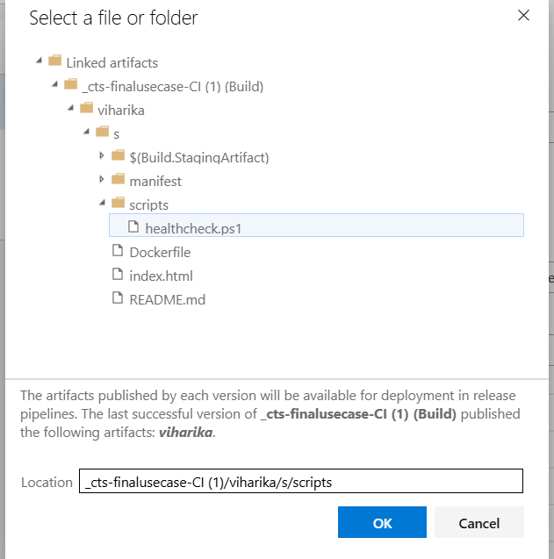

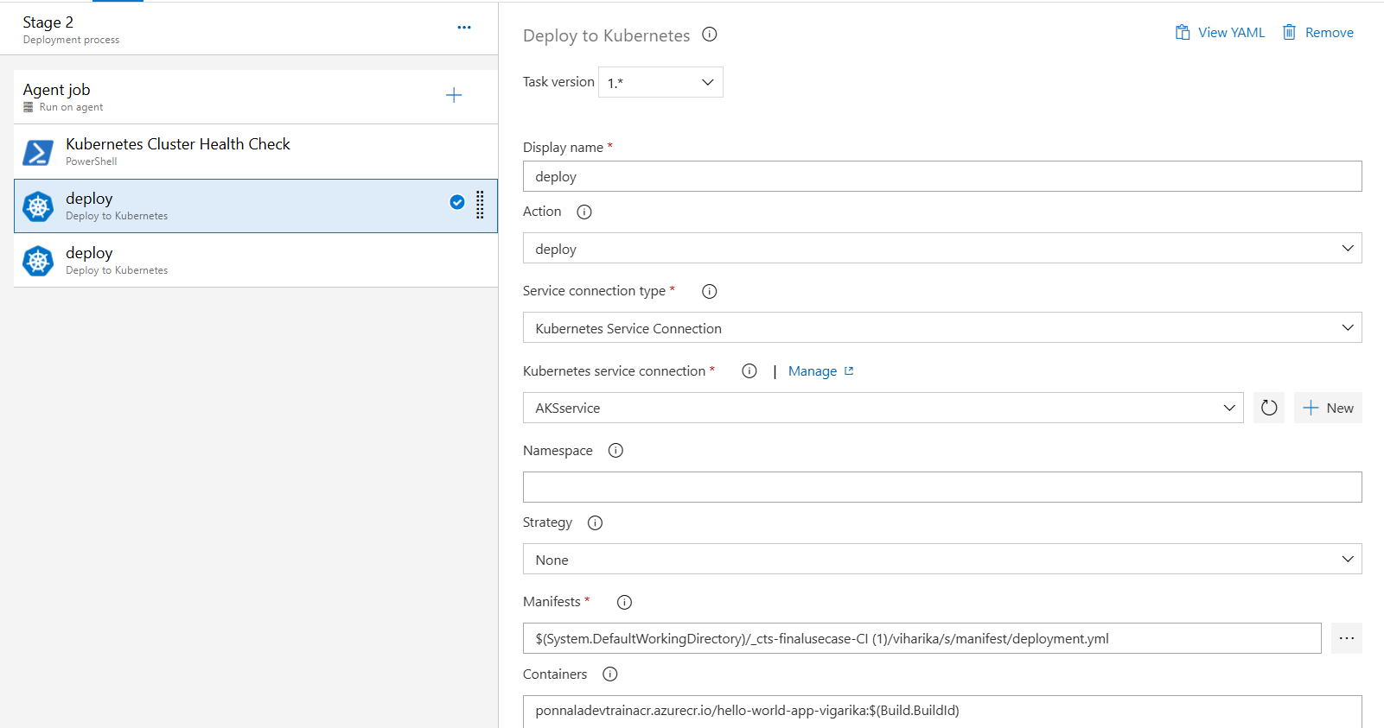

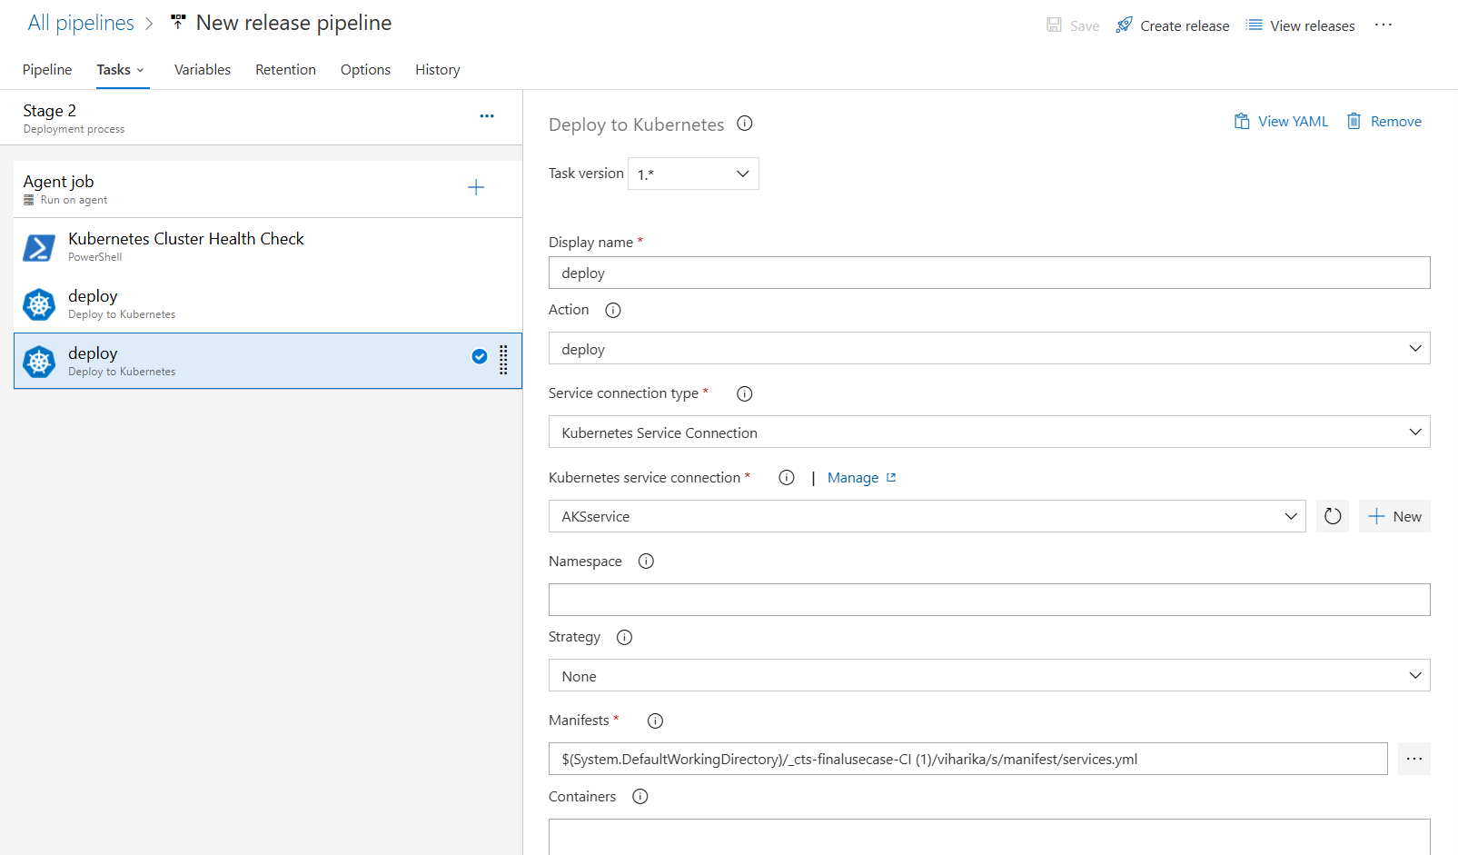

**CD pipeline-Release pipeline**

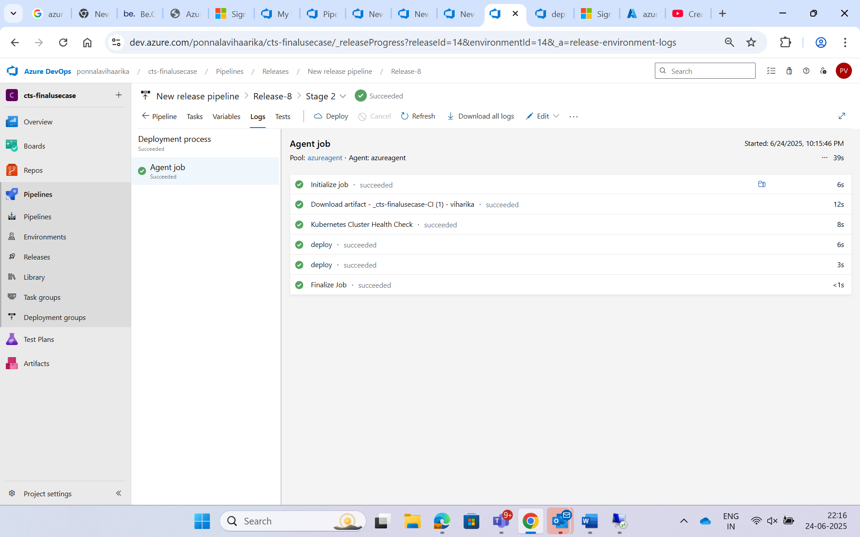

1. **Initialize Job**  
   Prepares the environment to run deployment tasks.

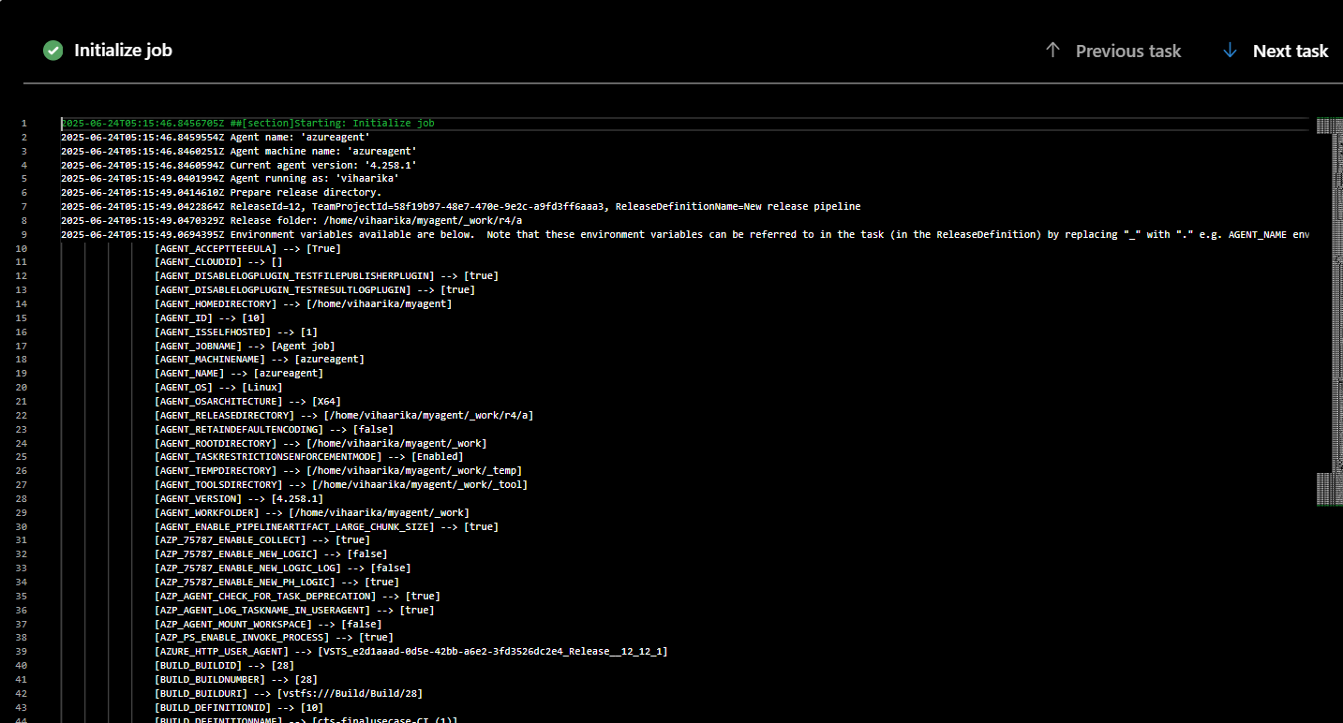

1. **Download Artifact**  
   Downloads the build artifacts (Docker image details) from the CI pipeline.

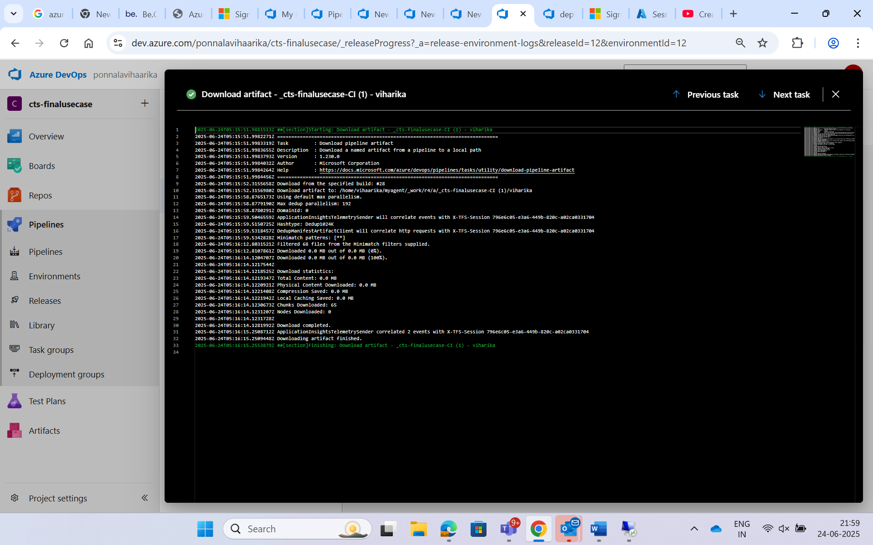

1. **Kubernetes Cluster Health Check**

Before deploying an app to a Kubernetes cluster, it’s important to **make sure the cluster is healthy**. That means:

* + - The **nodes** (machines running your containers) are working
    - The **pods** (containers inside Kubernetes) are running properly

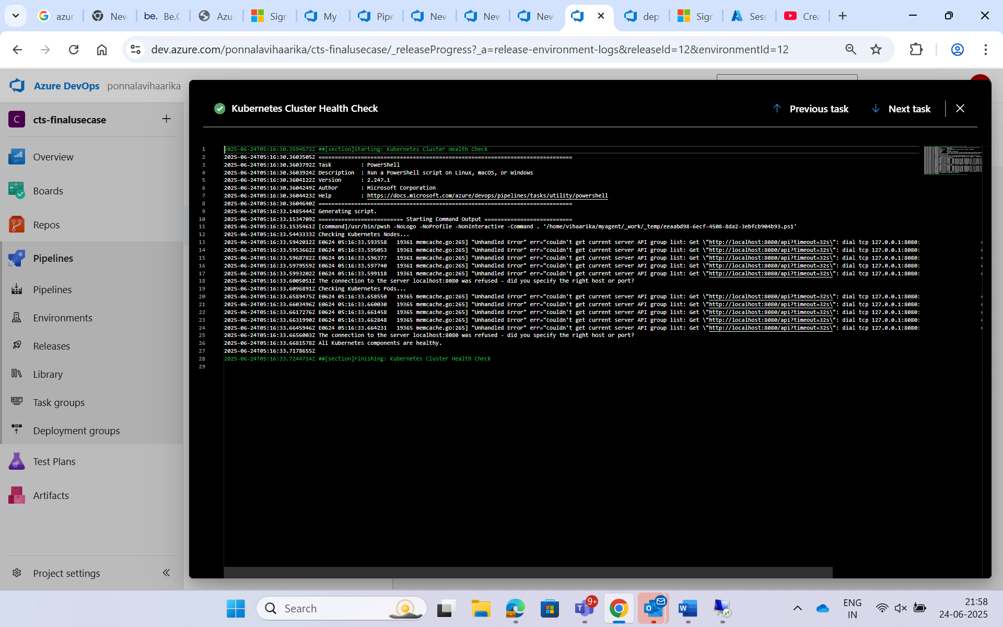

**Deploy**  
Applies the deployment.yaml and service.yaml using kubectl to deploy the app on AKS.

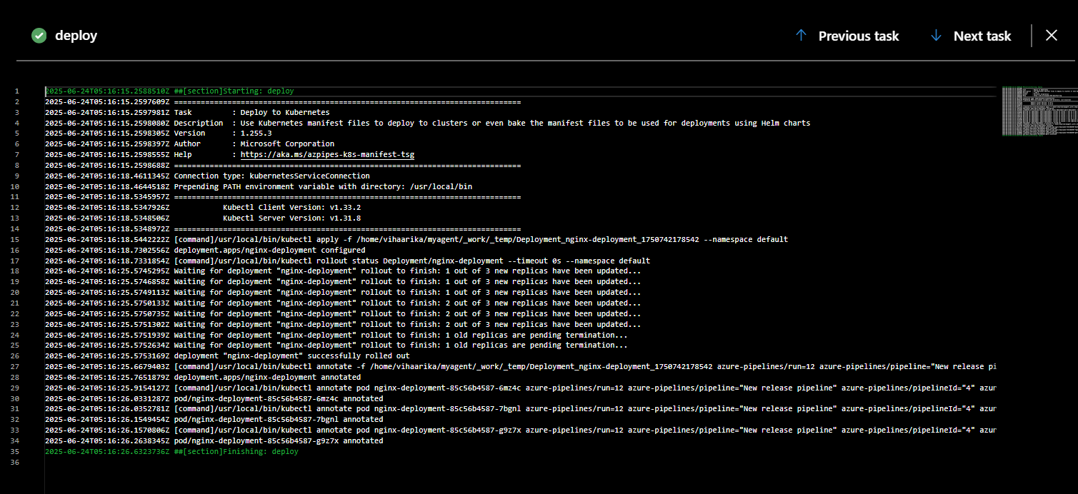

**Deploy (Step 2)**  
Confirms service exposure (like creating LoadBalancer and getting public IP).

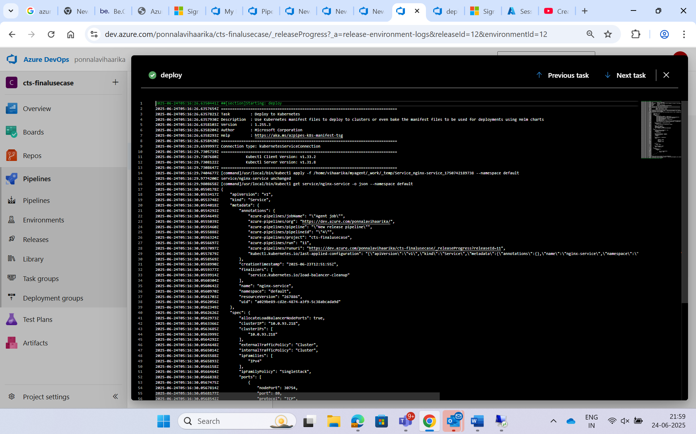

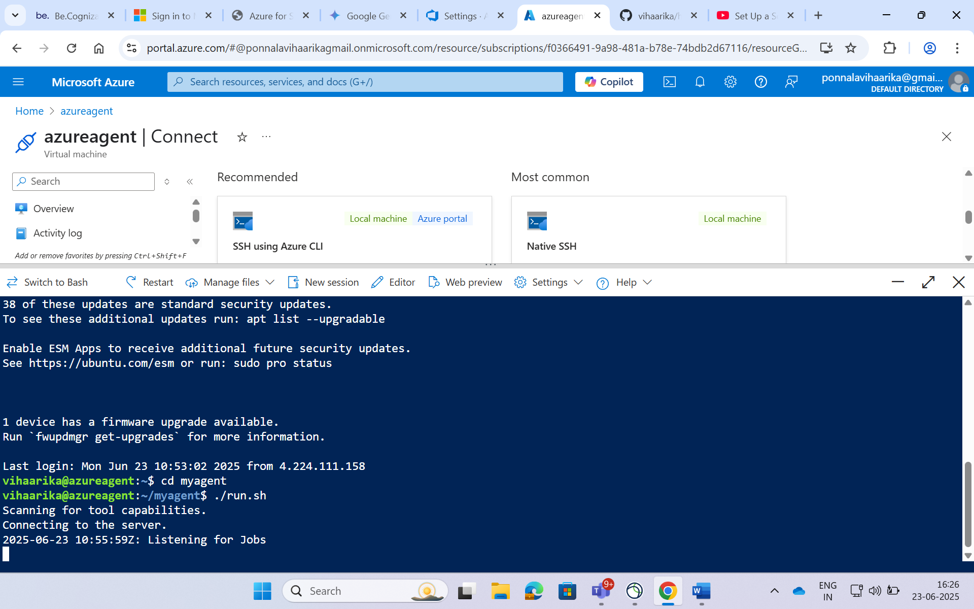

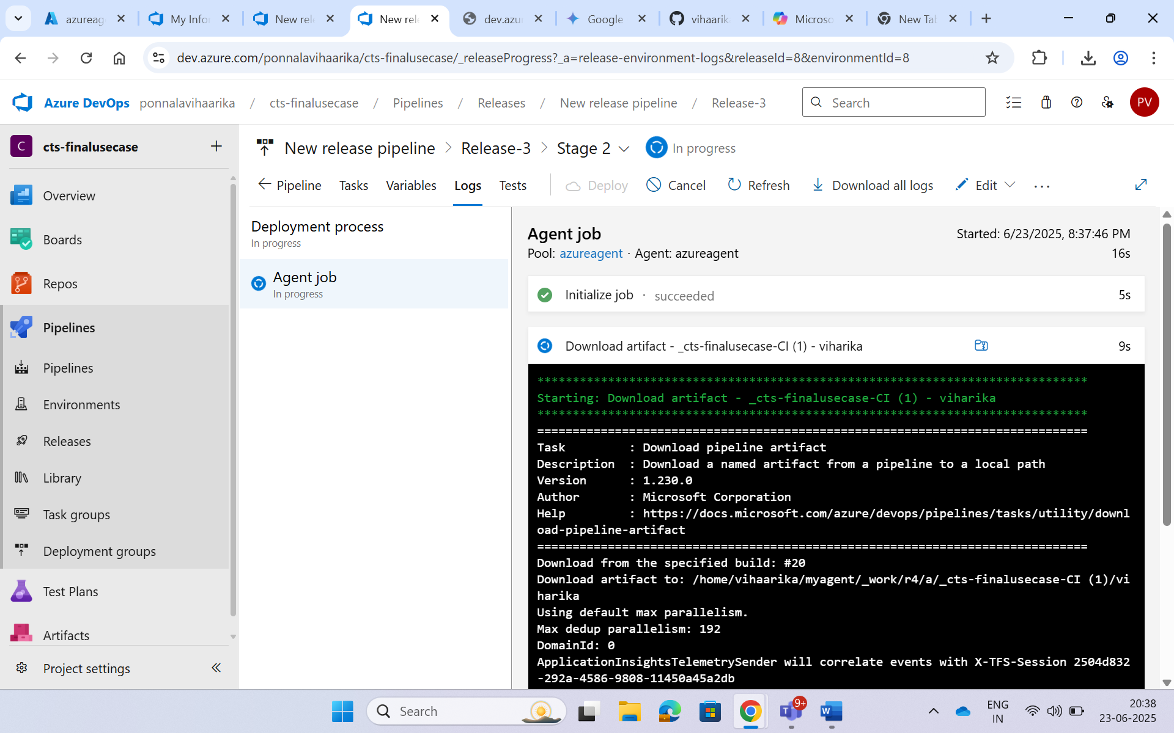

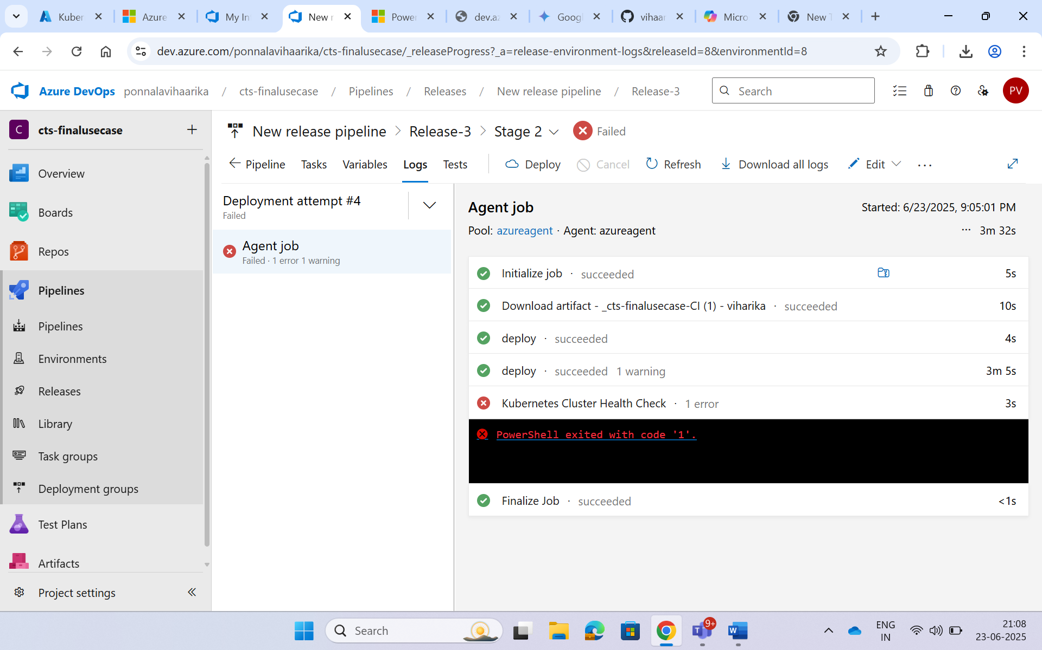

# Import the Microsoft GPG key

wget -q <https://packages.microsoft.com/config/ubuntu/22.04/packages-microsoft-prod.deb>

sudo dpkg -i packages-microsoft-prod.deb

# Update again and install PowerShell

sudo apt-get update

sudo apt-get install -y powershell

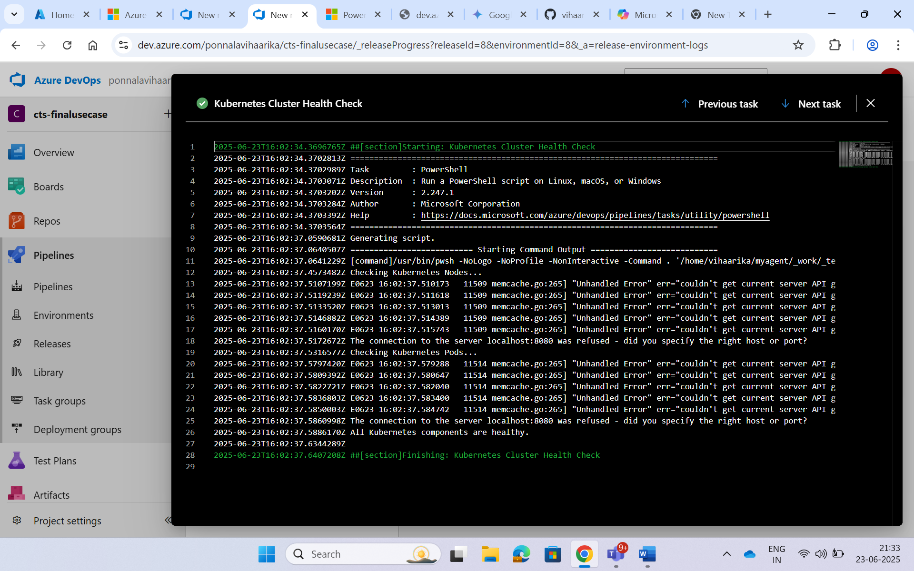

**6.Finalize Job**  
Cleans up and completes the release process.

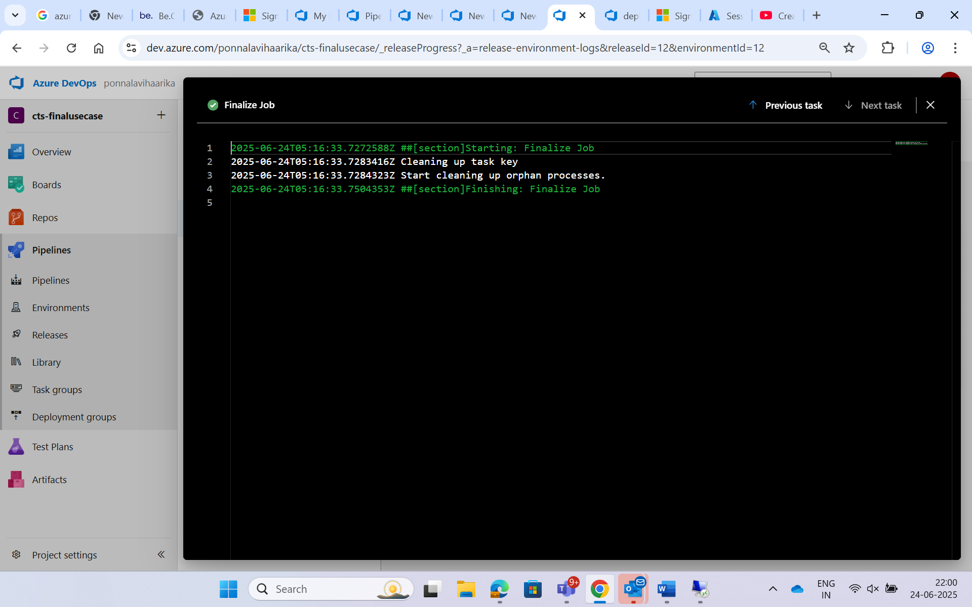



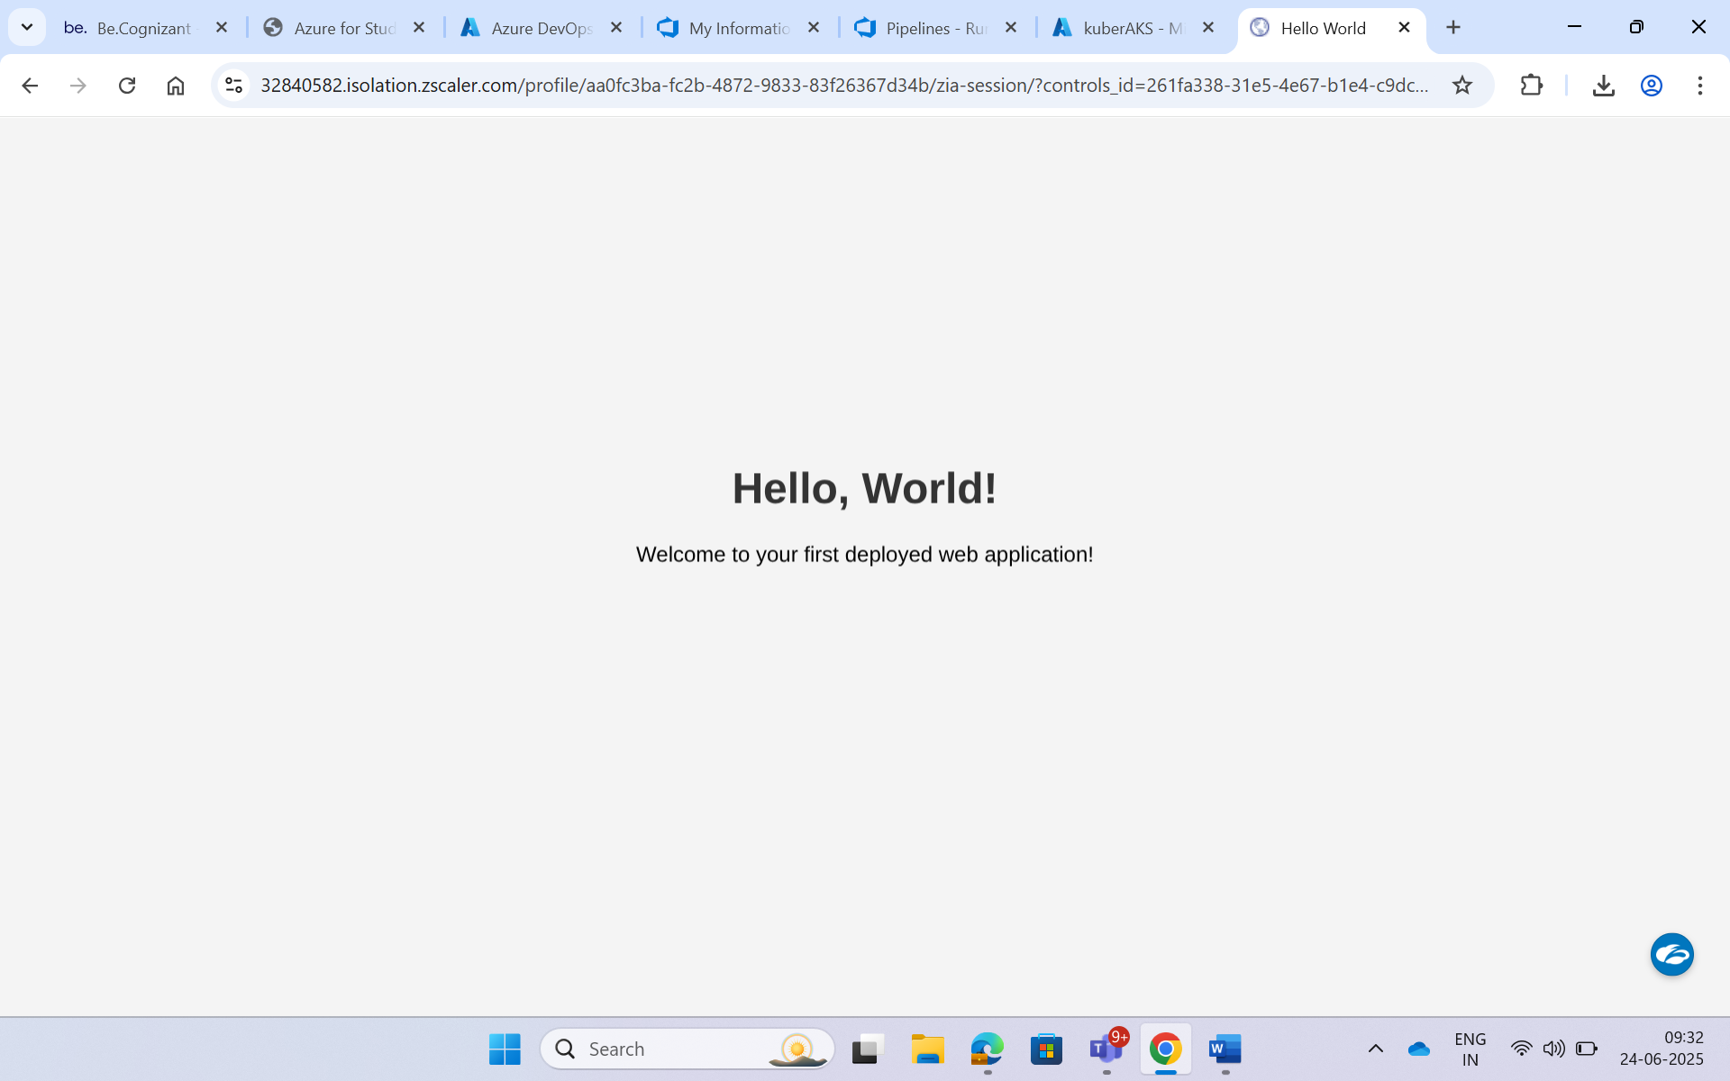

**1. You make a change in your code**

**2. Push that change to the main branch in your Git repo**

**3. Azure DevOps automatically triggers the CI pipeline**

* It **clones your repo**
* **Builds the Docker image**
* **Tags it using $(Build.BuildId)**  
  (e.g., if it’s the 115th build, it becomes: hello-world-app:115)
* **Pushes** the new image to Azure Container Registry (ACR)

**4. Then the CD (Release) pipeline starts automatically**

* It picks up the **latest build**
* Pulls the **correct Docker image (e.g., :115)** from ACR
* (Optional) **Runs health-check.ps1**
* Then **deploys the new version** of the app to AKS

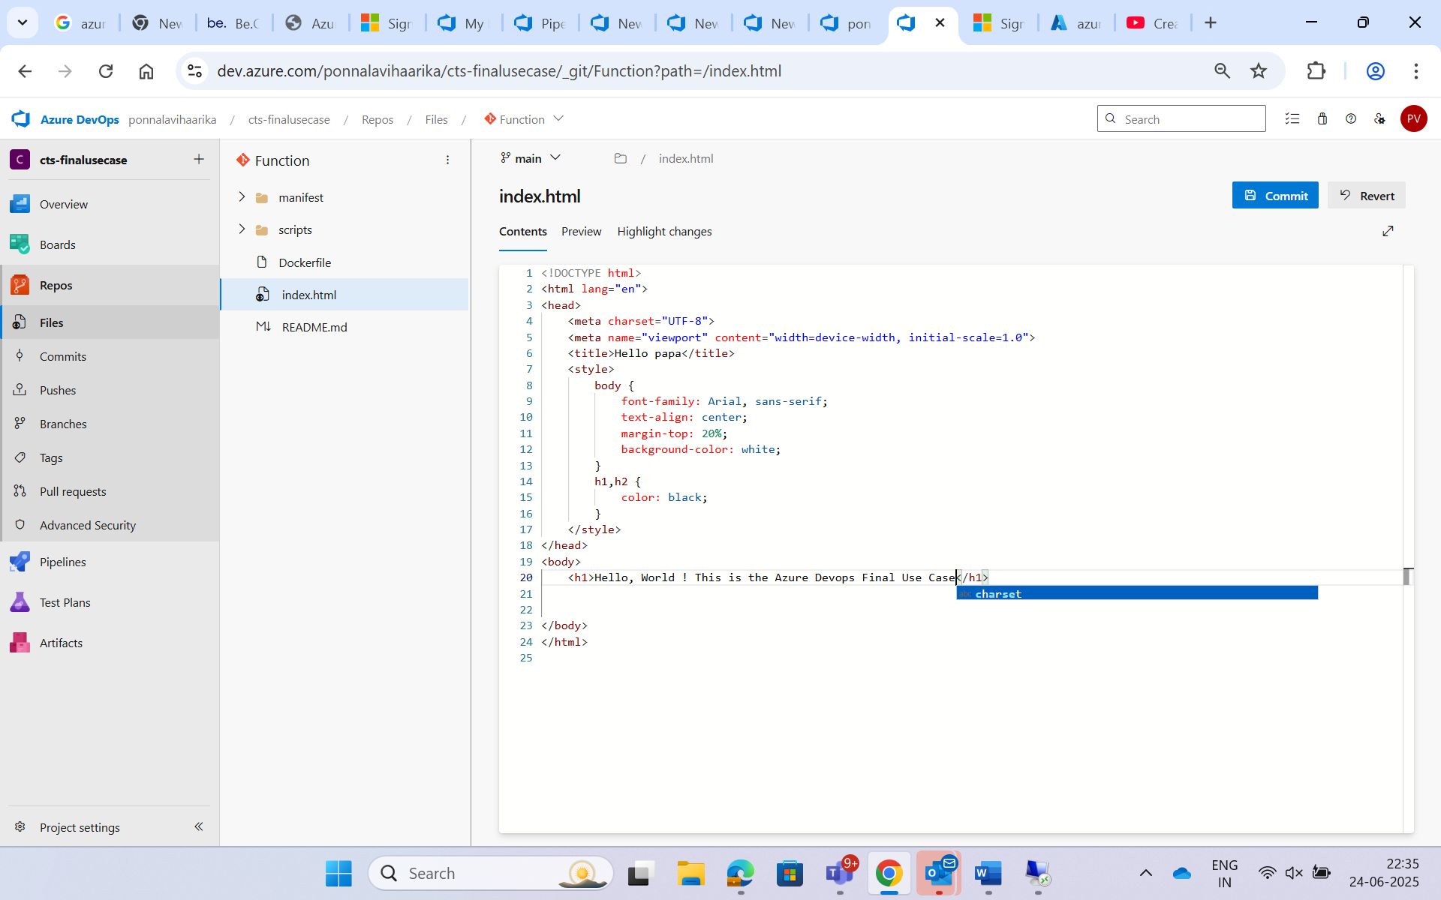

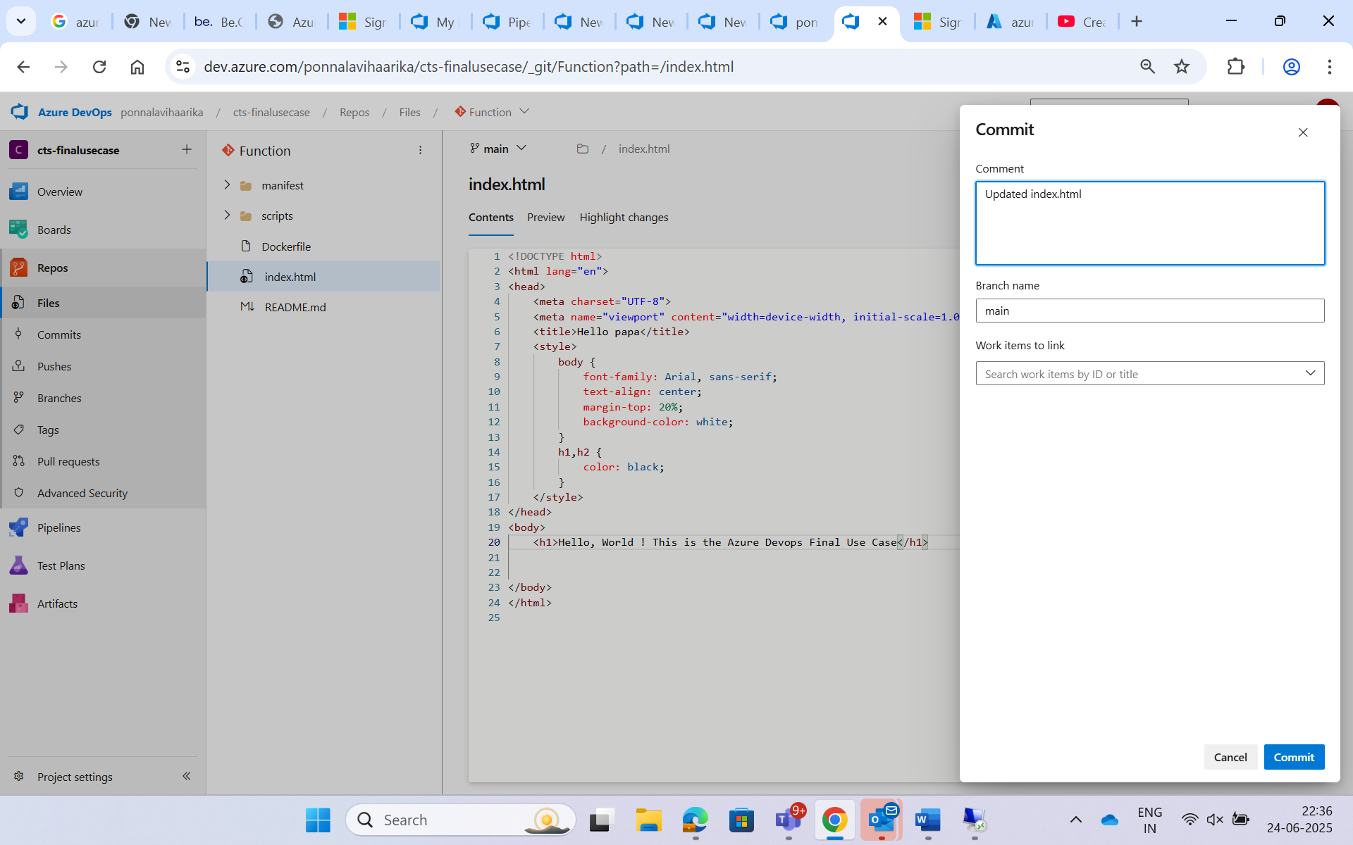

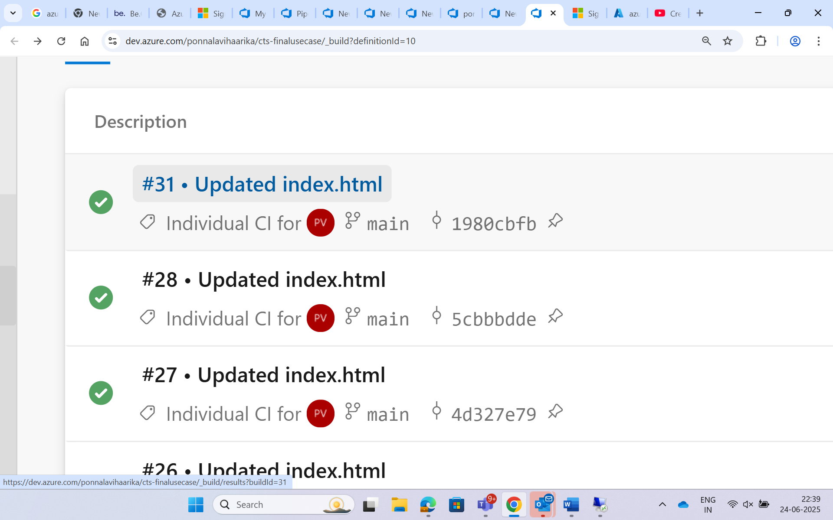

The Pipeline got Triggered when we commit a change. 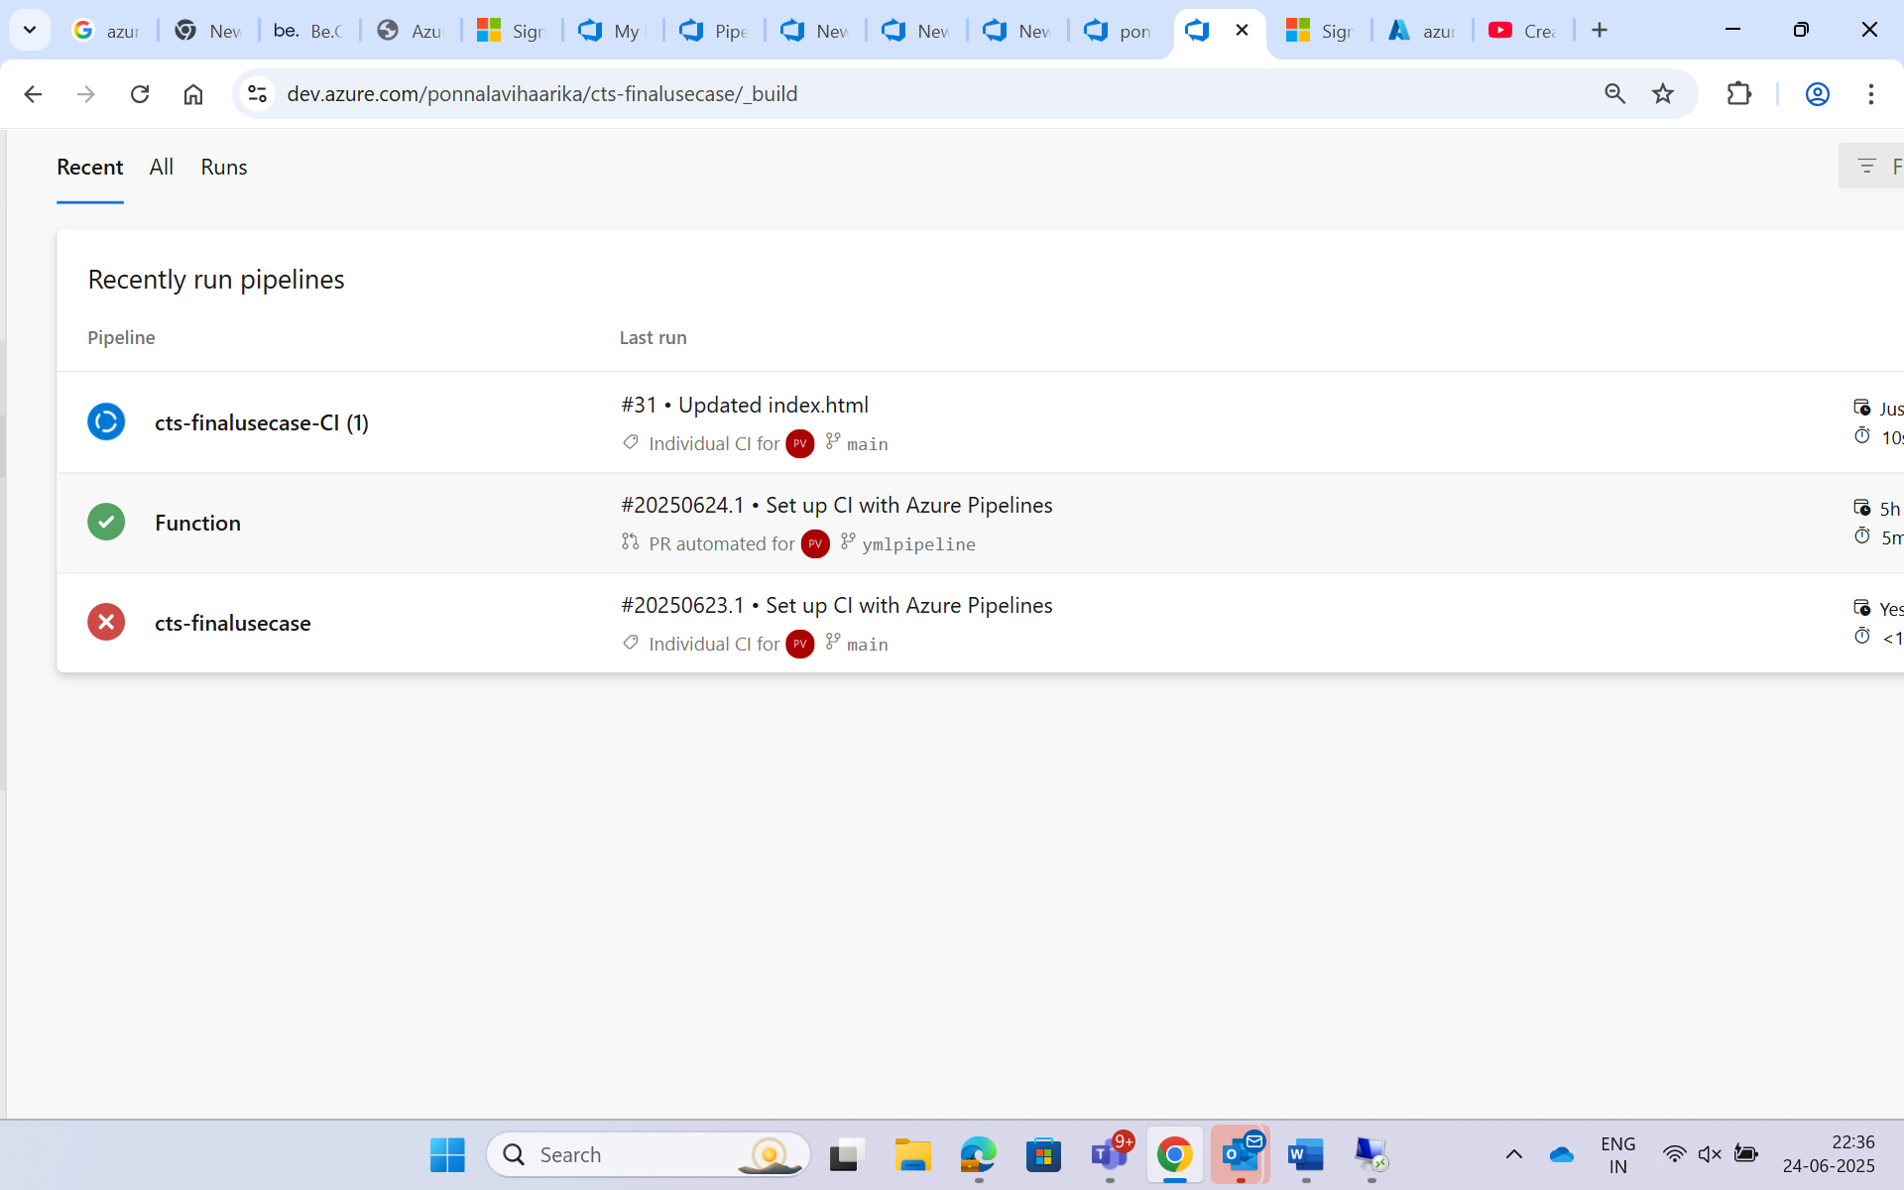

So once the Artifacs is generated then it triggers the release pipeline automatically .

